Graduate Faculty (GF) Nomination & Approval Process
(Regular, Cooperating, and Affiliate Graduate Faculty)
Instructions
Nominating a new member or requesting a change to a member’s GF appointment:
Access the nomination form: (need to use UH VPN if accessing Kuali Build forms from off-campus)
- Graduate Division Nomination & Appointment of Faculty webpage
- Or, use image below (i.e., direct link to the form):
Place mouse on image. Hold CTRL and click on the image
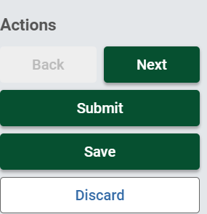
Select Next

Submitter of nomination form:
- Graduate chair or designated program staff member (e.g., program assistant, or secretary) who would complete the nomination form.
  - Role is Submitter
  - Submitter may also be an approver in the approval process (i.e., if Graduate chair is also a Submitter).
Complete the nomination form:
- Include all required* information:
  - Name of college/school*
  - Name of department (optional and, as relevant)
  - Name of graduate program*
  - Name of nominee*
  - Type graduate faculty appointment* (click Regular or Cooperating for Level to appear)
  - Level of graduate faculty appointment* (for Regular and Cooperating only)
  - Comments (i.e., information as appropriate or necessary)
  - Justification for the nomination*
  - Nominee’s research* - please note it’s 200 characters, not words, including spaces
  - Nominee’s current CV* (select a file to upload)
    - Redact or remove any sensitive information not publicly available
  - [For Affiliate Graduate Faculty only - a request for a non-comp PNF to HR is also necessary (please follow current procedures for that process).
    - HR will receive a copy of the nomination form after approval by the Dean/Director].

- Identify approvers for the Approval Workflow:
  - Type in name of Graduate Chair, Department Chair, Dean/Director, and for Affiliate Graduate Faculty only, Human Resources:
    - Select their name as it appears in the list
    - If a designee is necessary, please note reason for the designee in the Comments box above
  - The approver at each step in the Approval Workflow will receive a notification email when it is their turn to review and approve.
  - If a situation arises and assistance from Graduate Division is necessary
    - Please email: graddiv@hawaii.edu
Submission and Notification:
- Click Submit when the form is complete and CV is attached.
  - For Affiliate Graduate Faculty Only:
    - Initiate request for non-comp PNF if not yet done.
- Submitter will receive a notification email upon submission and after each approval step.
Approval Actions:
- Each approver in the workflow will receive a notification email when the form is ready for their review and approval. A link to access the form is included in the email.
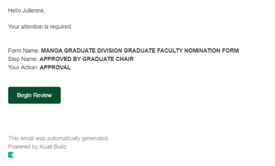
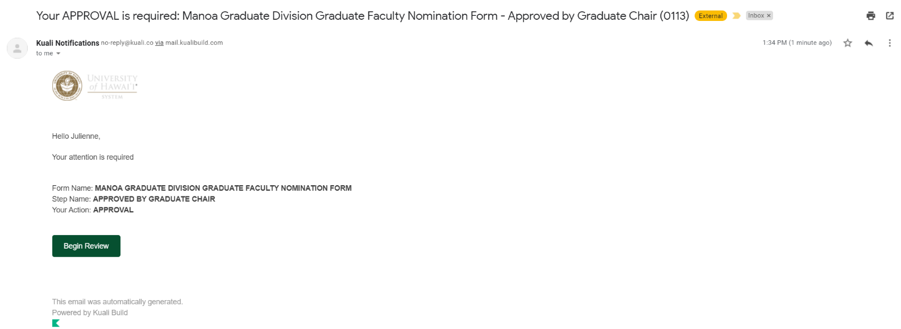
- If approving and off campus, the UH VPN is required to access the form.
- Click on Begin Review in the Notification message to review the form
- When ready to approve, click Approve (a comment is not required)
- If necessary, the form can be Saved and action taken later
- If a form is Denied, the workflow stops. A Comment is required and a notification that the nomination was denied is sent to the Submitter. The comment can be seen in Status view
- If the Send Back option is selected, the form can be sent back to anyone in the approval workflow, including the Submitter
For Affiliate Graduate Faculty Nominations/Renewals Only:
- An acknowledgement notification email is sent to the designated HR person for their information and a copy of the nomination form prior to Graduate Division approval. A request for a non-comp PNF should have been sent to HR from the unit submitting the nomination form

Everyone in the approval workflow, including HR, will receive a notification email with an attachment of the approved Graduate Faculty nomination form. This email will be sent by the Kuali Build system after approval of the nomination by Graduate Division.

