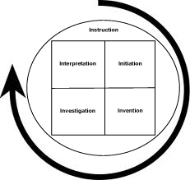
Building a talk: Telling your story

- Who is your audience?

- What is the most important element(s) of the scientific
discipline that you want to share with your audience?

Interpretation - WHAT IF?  What do you dream of discovering or being able to do in your career? | Initiation - WHY?  Why are you a scientist? Why did you become interested in science (age at first interest)?
Investigation - HOW?  How do you do your job? How does your job look on a daily basis and how does your research facility work (e.g. what equipment, procedures, communication do you use)? | Invention - WHAT?  What discipline of science do you study?  What scientific processes to do use?  What inspires you?
Instruction – Communication
How will you communicate to your audience and how will they communicate with you and each other?
Building a talk: Explaining your research
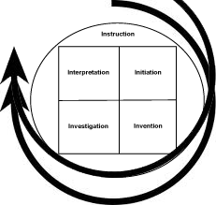
- Are there ways you can use multiple modes of inquiry
to showcase your research?

Interpretation - WHAT IF?  What if it works? What are the implications? What next? How will your findings affect the people in your audience? | Initiation - WHY?  Why is your research interesting?  Why is it important?
Investigation - HOW?  How are you collecting data and assessing conclusions? How does your study look so far? | Invention - WHAT?  What are the specifics of your organism, system or instrument development?
Instruction – Communication
How will you communicate to your audience and how will they communicate with you and each other?

