**TSI Lesson Reflection – TSI Phase Diagram**

Name: Diane Sands

Activity: My own activity - Bio Assessment

What level did you observe? ☑ Individual ☑ Pair ☑ Small group ☑ Full Class

Why did you observe this level? To examine how students practice observation skills and measured data on the river correctly.

Draw arrows indicating your progression through the TSI Phases of Inquiry. Number your arrows.

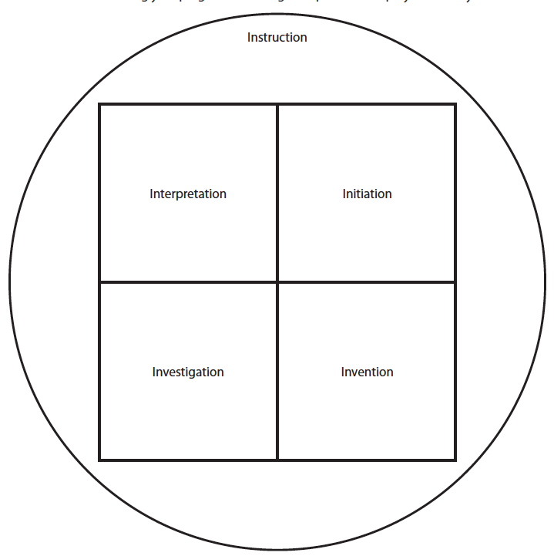

6

5 ⬅

2 ⬇

1⬆

3 ➔

 4