**TSI Lesson Reflection – TSI Phase Diagram**

Name: Diane Sands

Activity: Sampling for Abundance

What level did you observe? ☑ Individual ☑ Pair 🞎 Small group ☑ Full Class

Why did you observe this level? To examine how students understood bias and the methods of scientific sampling including haphazard, random, and census. I also wanted to observe how students use the Phases and Modes of Scientific Practice.

Draw arrows indicating your progression through the TSI Phases of Inquiry. Number your arrows.

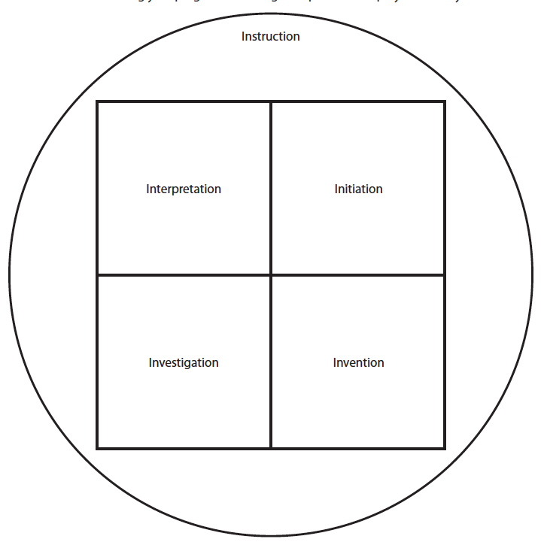

6 ⬅

5 

4 ➔

 2

7 

3 ⬇

1 ⬇

8 