TSI Lesson Reflection – TSI Phase Diagram

Name: Diane Sands

Activity: Phases and Modes of Scientific Practice
What level did you observe? ☑ Individual ☑ Pair Small group ☑ Full Class

Why did you observe this level? To examine how students understood the Phases and Modes of Scientific Practice and how it differs from the scientific method.

Draw arrows indicating your progression through the TSI Phases of Inquiry. Number your arrows.
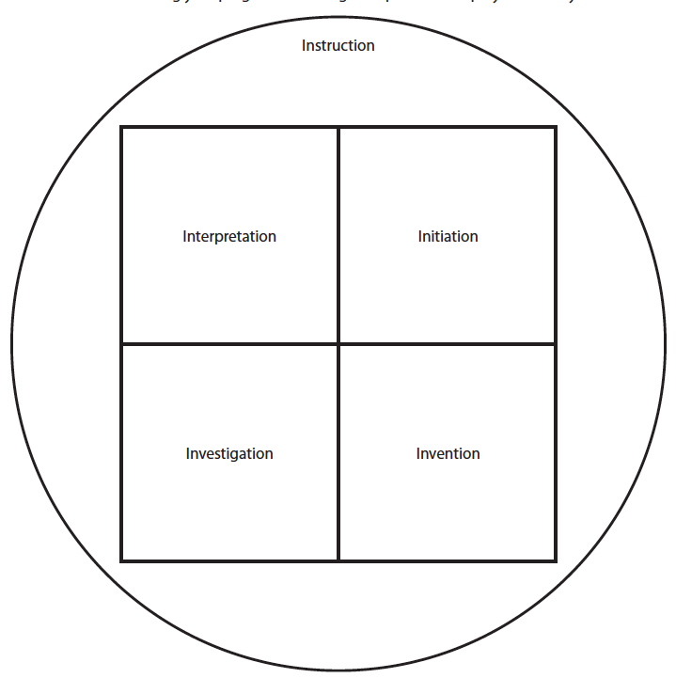
10 
9 
3 
8. 
6 
7 ⬇
5 ⬇
  
1 
2 ⬇
9 

