TSI Lesson Reflection – TSI Phase Diagram

Name: Diane Sands

Activity: Properties of Water
What level did you observe? ☑ Individual ☑ Pair Small group ☑ Full Class

Why did you observe this level? To examine understanding of the Properties of Water and students' understanding of adhesion and cohesion.

Draw arrows indicating your progression through the TSI Phases of Inquiry. Number your arrows.
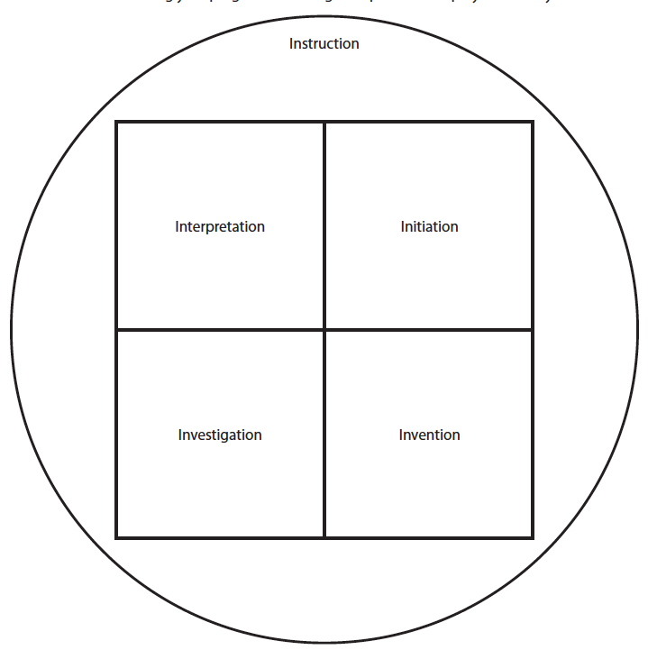
11 
 10
5 
  
 3
 2
7 
8. 
3 
1 ⬇
 6
9 

