In the workshop resources section, after clicking Module 1 Kauai or Module 1 Oahu (pick your cohort) on the right toolbar, click the blue box “Start”
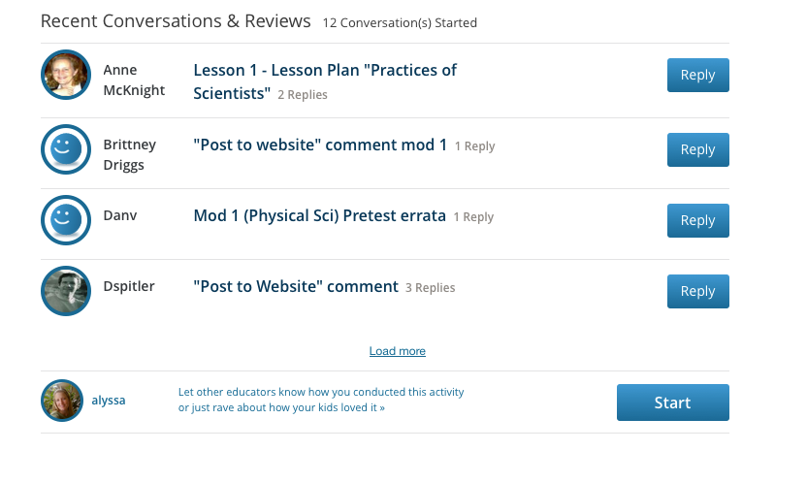
Write the body of your post, then click the “Upload” next to the Post blue button.
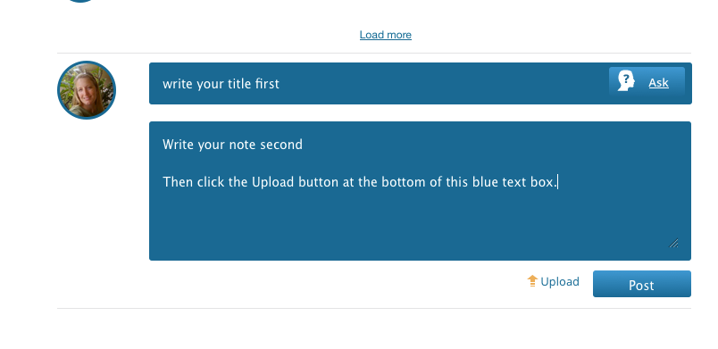

Click “Choose File”
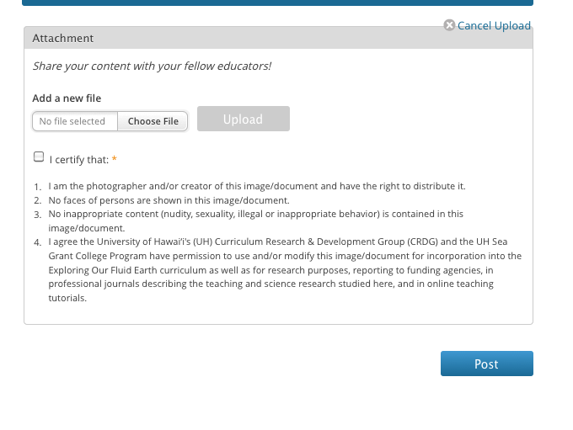
Pick the file you want to upload from your hard drive. It will upload automatically.
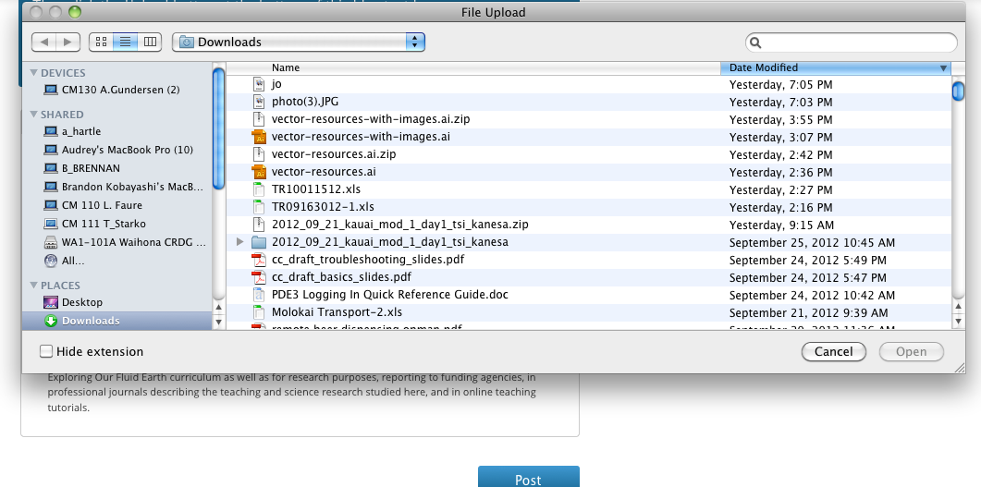
You will see the title of your file in the “Add a new file” box. Click the “I certify that” button.
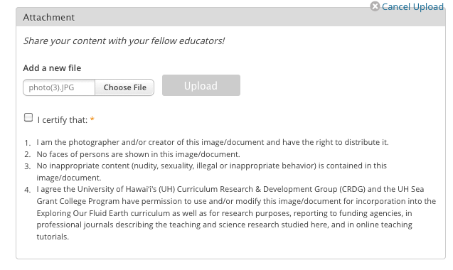
The Upload button will turn blue. Once it does, Click the Upload button.
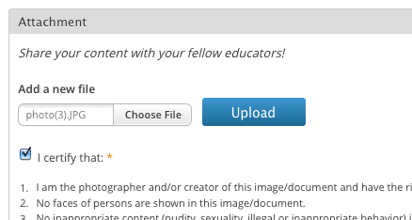

Click “Post” and your message will be posted on the website with attachment.
