Activity: Modeling Thermohaline Water Flow
Thermohaline water movement is caused by differences in both temperature and salinity (thermo- comes from the Greek word for temperature, -haline comes from the Greek word for salt). This activity models thermohaline water flow.

Materials for Parts A–C
- Two transparent plastic cups, thin enough to be easily punctured
- Nail or pencil
- Four pieces of masking tape
- Transparent plastic or glass box (shoebox sized)
- Small weights (e.g., coins or washers), number will depend on type of weight
- White paper
- Two beakers
- Food coloring
- Colored pencils or crayons in the same colors as food coloring
- Fresh water
- Towels

Additional Materials for Parts A and C
- Salt water

Additional Materials for Parts B and C
- Two beakers
- Heat source
- Ice bath (container in a tray of ice cubes and water)
- Thermometer

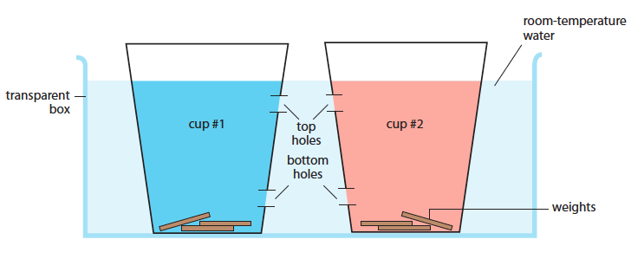
Fig. 2.19. Model system to simulate thermohaline circulation

Procedure

A. Test the effect of salinity on water flow.
- Study the apparatus shown in Fig. 2.19. The liquid in cup number one will be blue-colored salt water and the liquid in cup number two will be red-colored fresh water. The liquid in both cups will be at room temperature. Make colored sketches to show what you think the system will look like after one minute and after 10 minutes once the system is set in motion.

- Set up the system:
  - Obtain two transparent plastic cups. Make two holes in each cup as shown in Fig. 2.19. You can make the holes by firmly twisting a pencil point or nail into the plastic.
  - Cover both holes on each cup with one piece of masking tape. Make a tab or keep one end of the tape loose so that the tape can be removed easily.
    - If your plastic cups are large enough for your hand to fit inside and reach the tape tab, put the tape on the inside.
    - If your hand will not fit inside the plastic cups, the masking tape can be placed on the outside.
  - Put white paper behind and under the plastic box to make it easier to observe the colored water.
  - Put the cups next to the plastic box. Fill the box with clear room-temperature water to a level above the two holes on each cup, but lower than the rim of the cups.
  - Put the plastic cups in the water in the plastic box. Have your lab partner hold the cups down and add weights to the cups until they are stable.

- Color the fresh water red in a beaker. Color the salt water blue in a second beaker.

- Fill one of the plastic cups with the red fresh water up to the waterline in the box. Fill the other plastic cup with the blue salt water up to the waterline in the box.

- Make sure the holes in the two cups are facing each other. Peel off all of the masking tape as quickly and as smoothly as you can, disturbing the water as little as possible.

- Observe the movement of the water from the side of the plastic box and from the top. Make a series of colored sketches to record the pattern of any flow of water:
- as soon as the pieces of tape are removed
- after 1 minute
- after 5 minutes
- after 10 minutes

B. Test the effect of temperature on water flow.
- Referring to the apparatus shown in Fig. 2.19, make colored sketches to show what the system will look like one minute and ten minutes after the system is set in motion if the liquid in cup number one is blue-colored cold water and the liquid in cup number two is red-colored hot water. The liquid in both cups will be at fresh water.

- Set up the system according to the procedure described in A.2.

- Heat red-colored water in a beaker on a hot plate until it is 50–70 degrees Celsius (˚C). Chill cold blue-colored water in a beaker in an ice bath until it is ~5 ˚C.

- Fill one of the plastic cups with the red hot water up to the waterline in the box. Fill the other plastic cup with the blue cold water up to the waterline in the box.

- Make sure the holes in the two cups are facing each other. Peel off all of the masking tape as quickly and as smoothly as you can, disturbing the water as little as possible.

- Observe the movement of the water from the side of the plastic box and from the top. Make a series of colored sketches to record the pattern of any flow of water:
- as soon as the pieces of tape are removed
- after 1 minute
- after 5 minutes
- after 10 minutes

C. Model thermohaline water flow.
- Referring to the apparatus shown in Fig. 2.19, make colored sketches to show what the system will look like one minute and ten minutes after the system is set in motion if the liquid in cup number one is blue-colored cold salty water and the liquid in cup number two is red-colored fresh hot water.

- Set up the system according to the procedure described in A.2.

- Heat red-colored fresh water in a beaker on a hot plate until it is 50–70 degrees Celsius (˚C). Chill blue-colored salt water in a beaker in an ice bath until it is ~5 ˚C.

- Fill one of the plastic cups with the red hot fresh water up to the waterline in the box. Fill the other plastic cup with the blue cold salt water up to the waterline in the box.

- Make sure the holes in the two cups are facing each other. Peel off all of the masking tape as quickly and as smoothly as you can, disturbing the water as little as possible.

- Observe the movement of the water from the side of the plastic box and from the top. Make a series of colored sketches to record the pattern of any flow of water:
- as soon as the pieces of tape are removed
- after 1 minute
- after 5 minutes
- after 10 minutes

Activity Questions
- Explain how differences in salinity can cause
- vertical (up-and-down) movement of water.
- horizontal (sideways) movement of water.

- Explain how differences in temperature can cause
- vertical movement of water.
- horizontal movement of water.

- Explain how salinity interacts with temperature to cause movement of water.

- Do you think Part C simulated ocean circulation? Why or why not? What factors on earth affect real-world ocean circulation in ways that make it different from this model?

