TSI Lesson Reflection – TSI Phase Diagram

Name: ___Nichole Montague_______________________________

Activity: ___Soda and Scientific Reasoning____________________

What level did you observe? Individual Pair Small group √ Full Class

Why did you observe this level? ___I observed this level b/c I was facilitating for a class of 24 and I was interacting with many different lab groups constantly._____

Draw arrows indicating your progression through the TSI Phases of Inquiry. Number your arrows.
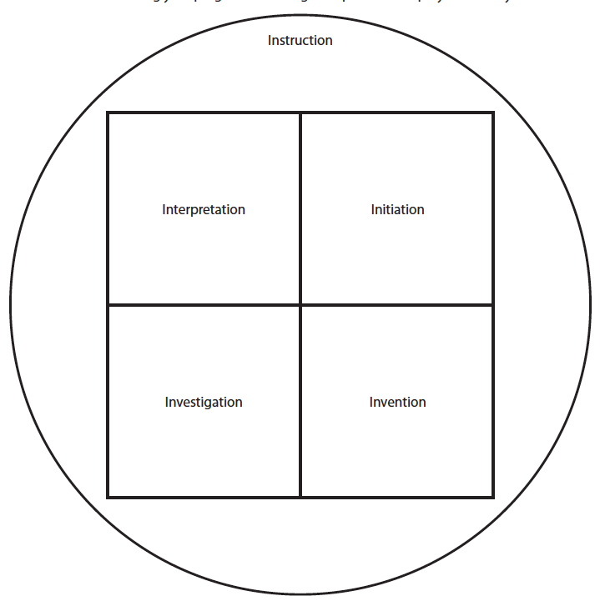

#11 Whole class sharing/teaching

#7 Discuss Results

#10 Evaluate Results/ Discuss

#9 Measure & Calculate
#8 Refocus - Calculate Density

#6 Record
#5 Experiment
#4 Predict/ Explain
#3 Discuss/ Variable list

#2 Discrepant
Demo
#1 Review

