Activity: Phases and Modes of Scientific Practice

When practicing science, it is important to monitor both your actions and your thought processes. Scientists use the word metacognition to describe the awareness of your thought process while you are thinking. Being metacognitive helps scientists effectively consider what they are doing and why. This activity will help you develop your metacognitive skills. This activity will also help you understand what scientists do and how they work by categorizing your actions and thoughts into phases and modes of scientific practice. Don’t worry if you feel a bit strange as you try to think about your thinking. Metacognition is a very important skill that takes time to develop!

Materials for Parts A-C
- A completed science activity that you will reflect on in this activity
- Table of steps in your scientific practice (Table 1.1)
- Figure of phases of inquiry (Figure 1.1)
- Table of Modes of Inquiry (Table 1.2)
- Pen or pencil

PART A – Steps of your scientific practice

Procedure
A. Record the steps (thoughts, communication, and actions) of your completed science activity.
- Record the name of the science activity you will be reflecting on at the top of Table 1.1.

- Think about the activity you just did, and try to remember each of the steps you took to complete the activity.
  - Include steps in which you did things physically (actions), steps in which you were thinking (thoughts), and steps in which you talked or communicated (communication).
  - Try to be as detailed as possible.

- Write down each step you took to complete the activity, in order, in Table 1.1, column A.

- Classify each step as an action, thought, or communication in column B
  - Leave columns C and D blank for now).
  - If necessary, you may list more than 13 steps by continuing onto another page.

Table 1.1. Steps of your scientific practice
Name of activity you are reflecting on:
Step | A.  What you did,  What you communicated, and/or  What you were thinking | B. Was this an action, communication, or thought? | C. Phase of Inquiry | D. Mode of Inquiry
1

2

3

4

5

6

7

8

9

10

11

12

13

PART B – Phases of Inquiry
When you write a lab report, you have probably been asked to follow the scientific method. In the typical scientific method reporting style:
- A question is used to develop a hypothesis.
- A hypothesis is used to design an experiment or research investigation.
- Data is collected through experimentation or research investigation.
- Results of the experimentation or research are analyzed to form a conclusion.

The scientific method is an important communication tool. Scientists all over the world share ideas using this standard format. However, the actual process of scientific discovery often has redirections, u-turns, and road-blocks that are ignored in the typical scientific method.

To capture the dynamic process of actual scientific discovery, scientists and educators developed the phases of inquiry (Fig. 1.1). Inquiry is a word that describes the investigating and questioning that scientists do. The phases help capture the ways scientists inquire.

The phases of inquiry are shown as a square surrounded by a circle (Fig. 1.1). There is no clear start or stop to the phases, just as there is no clear beginning or end of scientific discovery. There is no prescribed sequence that you need to follow. You can enter and exit each of the phases in any order, and multiple times, during a scientific investigation.

Procedure
B. Assign a phase of inquiry to each of your actions in Table 1.1
- Look carefully at the phases in Fig. 1.1. Notice that the outer circle is called “Instruction”, which is defined as a step where you “communicate and share information with others”. This communication can be a conversation with a partner, a group, a whole class, or a talk with your teacher. You can communicate by talking, listening, writing or reading.

- Use the definitions in Fig. 1.1. to assign a phase (initiation, invention, investigation, interpretation, or instruction) to each step you recorded in Table 1.1 column A.

- Record the phase next to its action, thought or communication step in column B.

- If necessary, you can change or modify the wording of the steps you recorded in Table 1.1 column A to help you align your steps with the Phases of Inquiry.

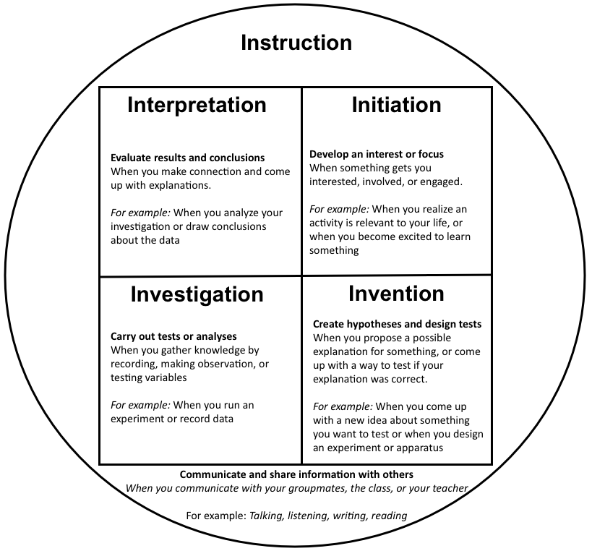

Fig. 1.1. The Phases of Inquiry

PART C – Path through the phases of inquiry

Procedure
C. Create a map of your path through the phases of inquiry
- For each step in Table 1.1, place the step’s number in the phase you assign it in Fig. 1.2
  - Start with step 1 in Table 1.1. Place the number 1 in the phase you assigned it in Fig. 1.2.
  - For step 2 in Table 1.1, place the number 2 in the phase you assigned it in Fig. 1.2.
  - For example, if you categorized step 1 as “invention” and step two as “instruction”, place a number “1” in invention and a number “2” in instruction.
  - Continue to write numbers for all of your steps in Table 1.1 in Fig. 1.2.

- Draw arrows in Fig. 1.2 to show your progression through the phases of inquiry.
  - Draw an arrow from the number 1 to the number 2.
  - In the example above, you would draw an arrow from the invention box to the instruction circle.
  - Continue drawing arrows for all of your numbers.
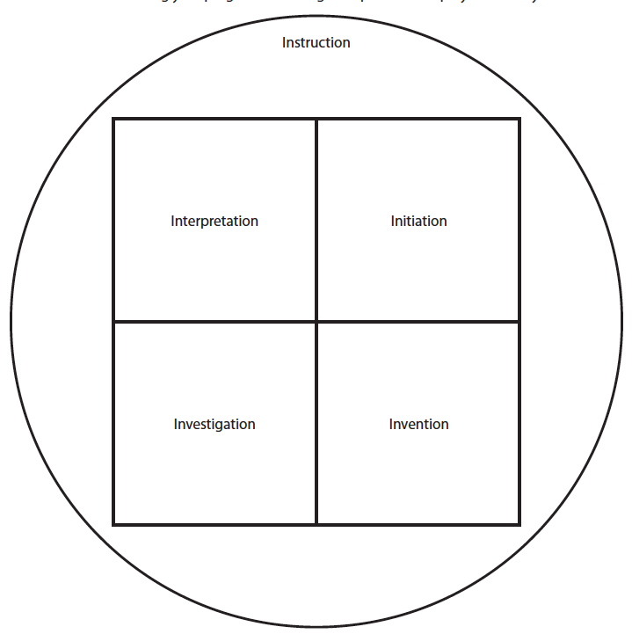

Fig. 1.2. A phase diagram lets you draw your path and show your progression through the Phases of Inquiry

PART D – Modes of Inquiry
Science is practiced in many different ways. The phases of inquiry describe the overall stages of inquiry. The Modes of Inquiry describe the many different ways scientists practice inquiry (Table. 1.2). There are many different modes to describe the different ways scientists gain knowledge.

Procedure
D. Assign a mode of inquiry to each of your actions in Table 1.1
- Look carefully at Table 1.2.
  - Notice how only the experimentation mode requires a full-scale experiment. The other modes show that there are many ways to gain scientific knowledge and engage in scientific inquiry.
  - For example, authoritative inquiry is the evaluation of information from an established source, like a reliable book or a reputable website. Authoritative knowledge is an excellent example of true scientific inquiry that is not experimental.

- Assign a mode of inquiry to each step you took during your activity in Table 1.1 and record the mode in column D.

Table 1.2. The Modes of Inquiry
Inquiry Mode | Description
Curiosity | An emotion that leads to questioning and discovery.
Description | Careful and accurate description of things or events.
Authoritative  Knowledge | Consultation of books, websites, teachers, or classmates who have expert knowledge.
Experimentation | Test of predictions made from hypotheses.
Product Evaluation | Comparison of the pros and cons of different equipment, procedures, or products.
Technology | The use of tools and techniques.
Replication | Duplication of something observed, heard about, or read. Or, a test to see if something can be repeated.
Induction | The use of existing data to find patterns and relationships.
Deduction | The Collection and analysis of information to develop a hypothesis.
Transitive knowledge | The use of knowledge from one field in a different field.
ACTIVITY QUESTIONS

Parts A-C. Phases of Inquiry
- How many phases did your steps fall into? List all of the phases you did in your activity.

- Did each Phase of Inquiry happen at the same time throughout the activity? For example, did you do all of the “instruction” steps at once, or did you do instruction throughout the activity?

- Look at your phase diagram to answer the following questions.
  - Which phase did you go to the most?

  - What phase did you go into the least?

  - What do you think this means about your thought process?

- Do you think you spent an equal amount of time in each Phase of Inquiry? Explain why you did or did not divide your time equally among the phases.

- Do you think that the amount of time spent in each Phase of Inquiry would be the same if you did a different activity? Why or why not?

- In general, how do you think your physical steps (actions) related to your thinking steps (thoughts) and talking steps (communication)?

Parts A & D. Modes of Inquiry
- How many Modes of Inquiry categories did your steps fall into? List all of the modes you did in your activity.

- Did each Mode of Inquiry happen at the same time throughout the activity? For example, did you do all of the “curiosity” steps at once, or were you in the “curiosity” mode throughout the activity?

- Which Mode of Inquiry phase did you go to the most? Why do you think you spent the most time in this mode?

- Do you think a different activity would cover the same modes? Why or why not?

Phases and Modes of Inquiry
- How do you think the phases and Modes of Inquiry reflect the actions, thoughts, and communication of professional scientists?

- Compare your Table 1.1 to a classmate who did the same activity.
  - How similar are your phases of inquiry and Modes of Inquiry categories?

  - What do you think this shows about the similarities and differences of your thought processes?

- Did you ever assign (or want to assign) more than one phase or mode to a step? Why or why not?

- Read the paragraph and then respond to the writing prompt:

Metacognition is thinking about thinking. In science class, this means thinking about the process of science. Metacognition is evaluating what you currently know and determining what you still need to learn. Metacognition is also about knowing how to get yourself engaged in learning. In the Phases of Inquiry, this is called the “initiation” phase. Sometimes your teacher can help you get “engaged” or “initiated”, but a lot of the time you have to do this yourself. It is important to be able to realize when you are not engaged and learn how to re-initiate yourself. This will help you when you have to learn something that is hard, that you might not find interesting, or that is not being presented in a way you like. Taking control of your metacognition allows you to take ownership over your learning, making it more enjoyable and more effective.

Writing prompt: Think of a time in this class you were not interested in an activity. Describe the activity and then describe a way you could have re-initiated yourself to become more engaged and interested.

