**Teaching Science as Inquiry (TSI) Lesson Plan**

**Module 4: Ecological Aquatic Science**

Name: Dan Bobrowski

Activity: What is Alive? (Choice activity)

1. Why did you choose to do this activity?

It was an activity that we had done at a previous workshop that I had enjoyed and a student question directly pertaining to the activity had come up in class. The activity addressed the student question about life on other planets in a fun and engaging way for students.

2. What are your classroom learning goals?

I will be able to:

* Name 2 things that make something alive
* Describe and explain a misconception about living things

3. How does this activity tie into your classroom learning goals?

I planned specific learning goals aligned to this activity for the classroom on the day of this lesson.

4. What date do you plan to start this activity? April 22 – April 23

5. *If applicable:* HIDOE standards this lesson will address none

6. Describe how this activity relates to at least one of the TSIA PD Themes.

Themes: Community, Metacognition, Science as a Human Endeavor, Observations and Inference, Modeling Science, Scientific Language, Connections

I believe this activity most fittingly relates to the “science as a human endeavor” theme because students are ultimately grappling with the question: What sets living things apart from non-living things? In so doing, they are exploring their differences from other living things and non-living things.

**Ocean**

7. Describe how you will connect this activity to the ocean:

The activity will be connected to the ocean through the example objects that I choose to use. When I did it with my students, I used a Hawaiian Monk Seal and a coconut as two of the sample objects.

8. Select the Ocean Literacy Principle(s) that you anticipate this activity will address. (check all that apply)

□ 1. The Earth has one big ocean with many features.

□ 2. The ocean and life in the ocean shape the features of the Earth.

□ 3. The ocean is a major influence on weather and climate.

□ 4. The ocean makes earth habitable

□ 5. The ocean supports a great diversity of life and ecosystems.

□ 6. The ocean and humans are inextricably interconnected

□ 7. The ocean is largely unexplored

**Preparation**

9. How will you prepare your students for this activity? (For example, review of prior knowledge.)

I plan to get students ready for the activity by referencing the question that a student asked in class about life on other planets. I will say that we are going to explore that question with another question today: What does it mean to be alive?

10. Explain any instructional struggles that you foresee and how you will address these issues. (For example, student misconceptions, classroom discussion, aspects most difficult for students to grasp, etc.)

I anticipate that students will run into difficulties when trying to categorize some of the objects as either living or non-living (such as the seed and fire). I will encourage students to work through difficult discussions with their groups by telling them that the objects are meant to bring up argument and disagreement and after their discussions, I will explain to them how scientists categorize each object and why.

11. What ***TSI inquiry questioning strategies*** will you use to help your students meet your learning goals?

What types of questioning or approaches to discussion will you take to support student

engagement and learning? See questioning handout for suggestions (Mod 3 Binder under “TSI Pedagogy and online in Mod 3 PD section)

During the Duco Cement demonstration, I will ask students to elaborate on statements such as, “It’s moving!” I want students to get to the root of what they are saying, which was that they believed the “cement monsters” to be alive. At this point in the lesson, I also anticipate the need for focusing questions to pull students back to the main focus of whether or not the cement monsters are alive, should they stray too far from the topic.

When we revisit the Duco Cement example at the end of the lesson, I will ask students what they would like to know about it…and then ask WHY they want to know that. This will give students a chance to show that they are looking for pointed information and that they understand and can apply the concepts covered in the lesson.

12. What ***TSI practices of inquiry teaching strategies*** will you focus on implementing to help your students meet your learning goals?

I will utilize the “Science as a Discipline” strategy as I will stress the idea to students that the question of “What is alive?” is still a question that scientists are grappling with today. I will give them the example of viruses, which do not have cellular structure, but can facilitate reproduction and can maintain and manipulate their environment. My aim is to present science as an ever-changing discipline – one in which everyone can participate in the question asking and exploration phases as we collectively work to learn more about the environment that surrounds us.

I will utilize the “Teacher as Research Director” strategy as I will put a great deal of responsibility and ownership on student groups to grapple with, discuss, and explore the difficult questions presented in this lesson. I will go into the lesson knowing that each group will likely go about the exploration in a different way, but that is fine considering that ownership of the learning experience will make it that much more meaningful in the long run.

|  |
| --- |
| Use the following table to plan your lesson using TSI.  For each phase:   * **Teacher:** Describe what you will be doing * **Student:** Describe what your students will be doing * **Assess:** Describe how you will assess your students in this phase so you can monitor their progress through the activity |

|  |  |  |  |
| --- | --- | --- | --- |
| **INTERPRETATION** | | **INITIATION** | |
| Teacher | Revisit the Duco Cement Demo and ask students what information they would like about the object to determine whether it is living | Teacher | I will introduce the lesson as the response to a student question and will facilitate the Duco Cement Demo and encourage student observation |
| Student | Ask questions about the cement monsters | Student | Will listen, watch, and shout-out observations |
| Assess | Are students able to apply what they learned in the lesson? Are they asking meaningful questions? | Assess | Are students listening, watching, and verbally participating at appropriate times? |
| **INSTRUCTION** | | | |
| Teacher | Give students the 5 criteria the scientific community uses to classify living things as well as talk about how this is still an ongoing debate (case in point, viruses) | | |
| Student | Record the 5 criteria in the spaces provided on their worksheet. Listen to virus example | | |
| Assess | Are students writing the information? Are they attentive during the example? | | |
| **INVESTIGATION** | | **INVENTION** | |
| Teacher | Present each example object, tell a little about it, circulate the room to listen to and question group discussion | Teacher | Monitoring the individual brainstorm and group discussions, encouraging students to put down as many characteristics of living things as they can |
| Student | Examine each object and fill in the questions on the chart | Student | Brainstorming individually, then working as a group to narrow the brainstorm to 3 things |
| Assess | Are all students participating? | Assess | Are all students brainstorming? Are they all participating in their group discussion? |

11. Briefly describe how you will guide your students through the TSI Phases of Inquiry.

* Initiation – Refer to student question about life on other planets; Duco cement demonstration, having students shout out observations and questions.
* Invention – Students first work independently and then in groups to brainstorm 3 things that make something alive, recording these on the space provided on their worksheets
* Investigation – Students evaluate each example object and fill in the graphic organizer that asks for the following:

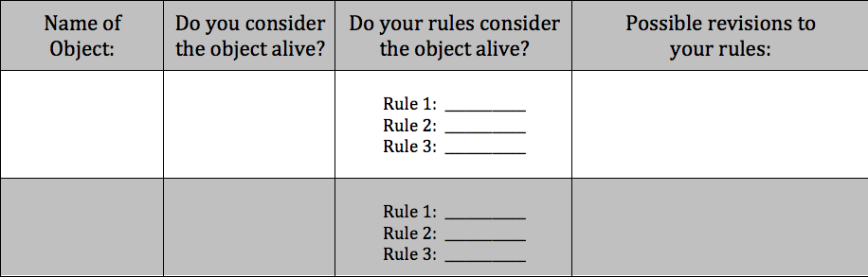

* Instruction – I relay the 5 criteria set by the scientific community that classifies something as living as well as give an example of why this topic is still up for debate (viruses)
* Interpretation – Students ask questions about the opening demonstration in an attempt to categorize the Duco Cement Monsters as living or non-living.

12. What *overarching* TSI mode(s) will you focus on for this activity? Why?

Modes: Curiosity, Description, Authoritative knowledge, Experimentation, Product evaluation, Technology, Replication, Induction, Deduction, Transitive knowledge

I believe the overarching modes for this activity are **product evaluation** and **deduction**. These are the overarching modes because the goal of the lesson is to have students synthesize general “rules” for what makes something alive. They then apply and evaluate these rules as they explore the categorization of specific objects throughout the lesson.

Please provide any additional comments that will help you prepare to teach this activity or help the TSI facilitators understand how you plan to teach this activity.

I produced a worksheet and a PowerPoint presentation for my rendition of the lesson, which I will gladly attach for others to use if they feel it aligns to how they would like to approach the lesson.