Teaching Science as Inquiry (TSI) Lesson Plan
Module 1: Physical Aquatic Science

Name: Dan Bobrowski

Activity: Density Bags

Why did you choose to do this activity?
Honestly, I chose to do this activity because it was a requirement of the TSI framework. I am of the opinion that I was provided with numerous activities that all illustrated density in a “less messy” and more student-friendly manner.

What are your classroom learning goals?
Since this activity was done during homeroom time (not during my instructional time), I did not have curriculum-based learning goals for it. However, I did show students learning goals at the beginning of the activity. These learning goals were as follows:
I will be able to:
- Define density.
- Explain and diagram the “density bags” experiment in terms of the different densities of fresh and salt water

How does this activity tie into your classroom learning goals?
The activity did not tie into the classroom learning goals. We are currently concluding our unit on the moon in my space science class.

What date do you plan to start this activity?
October 28 – October 29

If applicable: HIDOE standards this lesson will address
Benchmark: SC8.8.6 Explain the relationship between density and convection currents in the ocean and atmosphere

Ocean
- Describe how you will connect this activity to the ocean:
The last part of the activity was a discussion in which I guided students in connecting the activity to our previous activity on density (soda cans). Part of this discussion was an extension question I asked students to “think, pair, share” about. The question was: “What does this mean for water in the ocean? Where is the saltiest water? What about the water with the least amount of salt?” During the activity (when we were generating hypotheses), one student related the activity to his experiences swimming in the ocean and in pools. He related himself to the density bags and said that things put into the salt water tank would be more likely to float because he felt lighter in salt water.
- Select the Ocean Literacy Principle(s) that you anticipate this activity will address. (check all that apply)
1. The Earth has one big ocean with many features.
2. The ocean and life in the ocean shape the features of the Earth.
3. The ocean is a major influence on weather and climate.
4. The ocean makes earth habitable
5. The ocean supports a great diversity of life and ecosystems.
6. The ocean and humans are inextricably interconnected
7. The ocean is largely unexplored

Preparation
- How will you prepare your students for this activity? (For example, review of prior knowledge.)
I am having students start right into the activity by making the density bags. Then, they will generate hypotheses (during which they will HOPEFULLY be relating the material to previous knowledge). Finally, I will connect the dots and help them forge connections between this activity and the soda cans as the last part of the activity.

- Explain any instructional struggles that you foresee and how you will address these issues. (For example, student misconceptions, classroom discussion, aspects most difficult for students to grasp, etc.)
I foresee students having misconceptions about the SIZE and not the density of an object determining whether an object will sink or float. I also think they may have some misconceptions around which type of water (fresh or salt) would be “lighter” than the other. I will have larger Ziploc bags at the ready to fill with the fresh and salt-water samples to dispel the first “myth”. The activity is perfectly designed to dispel the second.

- Select the TSI Mode(s) of Inquiry that you will focus on for this activity. (check all that apply)
Curiosity
Description
Authoritative knowledge
Experimentation
Product evaluation
Technology
Replication
Induction
Deduction
Transitive Knowledge

Questioning and Assessment Strategies
- What questioning strategies will you use to help your students meet your learning goals?
Students will frequently be posed questions for them to think about, discuss with a partner (or small group), and then share out to the entire class. Such questions will involve generating hypotheses related to density and the relationship of fresh and salt water and the synthesis of the activity with both previous activities and life experiences.

- What assessment strategies will you use to help your students meet your learning goals and monitor their progress?
Students were required to complete a 2 question “quiz” on the activity and density before leaving the classroom. The questions were as follows:
- Explain why the salt water bags sank to the bottom of the fresh water tank.
- What would you predict would happen if you mixed sugar and water, put it in a density bag, and put the bag in a tank of fresh water?
Hint: Think about the floating and sinking sodas!

Please provide any additional comments that will help you prepare to teach this activity or help the TSI facilitators understand how you plan to teach this activity.

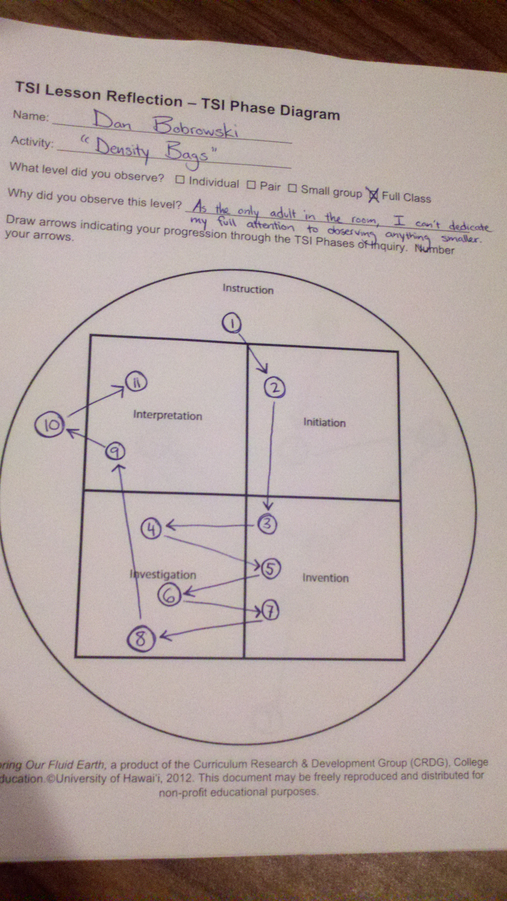
Phase Diagram:

