Name: __________________________________________________________ Period #______________

Modes of Inquiry (adapted from materials copyrighted to UH-CRDG-TSI)
Science is practiced in many different ways. The Modes of Inquiry describe the many different ways scientists practice inquiry (Table. 1.2). There are many different modes to describe the different ways scientists gain knowledge.

Procedure: Start by making a simple two-column table on a piece of lined paper. Call it Table 1.1. Think back to the three days we spent getting familiar with our microscopes. Make a list of in the first column of actions that we did during those days. Now, assign a mode of inquiry to each of your actions that you did during the three days we took to complete our Introduction to Microscopes lesson. (You can add more to the first column as you gain a better understanding of what actions the modes might apply.)

Look carefully at Table 1.2. Notice how only the experimentation mode requires a full-scale experiment. The other modes show that there are many ways to gain scientific knowledge and engage in scientific inquiry. For example, authoritative knowledge is the evaluation of information from an established source, like a reliable book or a reputable website. Authoritative knowledge is an excellent example of true scientific inquiry that is not experimental.

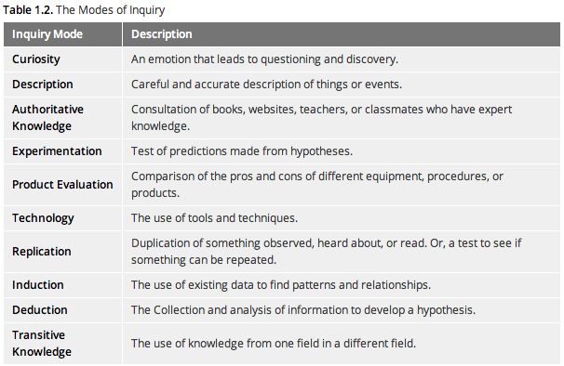

1. How many Modes of Inquiry categories did your steps fall into? List all of the modes you did in your activity.
______________________________________________________________________________________________________________________________________________
_______________________________________________________________________

2. Did each Mode of Inquiry happen at the same time throughout the activity? For example, did you do all of the “curiosity” steps at once, or were you in the “curiosity” mode throughout the activity?
______________________________________________________________________________________________________________________________________________

3. Which Mode of Inquiry phase did you go to the most? Why do you think you spent the most time in this mode?
______________________________________________________________________________________________________________________________________________

4. Do you think a different activity would cover the same modes? Why or why not?
______________________________________________________________________________________________________________________________________________

5. Read the paragraph and then respond to the writing prompt:

Metacognition is thinking about thinking. In science class, this means thinking about the process of science. Metacognition is evaluating what you currently know and determining what you still need to learn. Metacognition is also about knowing how to get yourself engaged in learning. In the Phases of Inquiry, this is called the “initiation” phase. Sometimes your teacher can help you get “engaged” or “initiated”, but a lot of the time you have to do this yourself. It is important to be able to realize when you are not engaged and learn how to re-initiate yourself. This will help you when you have to learn something that is hard, that you might not find interesting, or that is not being presented in a way you like. Taking control of your metacognition allows you to take ownership over your learning, making it more enjoyable and more effective.

Writing prompt: Think of a time in a class you were not interested in an activity. Describe the activity and then describe a way you could have re-initiated yourself to become more engaged and interested.
_____________________________________________________________________________________________________________________________________________________________________________________________________________________
_______________________________________________________________________

