Name _________________________________________________________ Date_______________________________

Conductivity Lab: Part 2 – Test the Conductivity of Different Substances

Purpose: Create an electrical circuit to investigate the properties of electricity.

Materials: What are the things you will need to do this experiment?
- battery pack LED light alligator clip connectors Petri dishes
- cup distilled water tap water salt water vegetable oil dark paper paper towels
- straightened paper clips

Procedures: What are the steps you will follow to do this experiment?
Part A – Test the conductivity of different solid materials.
- Create an electrical circuit that lights the LED light like you did in Part 1 of this lab.
- Pick three different solid materials to test for conductivity. One must be metallic, one non-metallic and another of your choice. List them below. #1 _____________________ #2______________________ #3_____________________
Predict the amount of light (none, dim, bright) and conductivity (none, poor, good) for each material. Record in Table 1.
Material | Predicted amount  of light  (none, dim, bright) | Predicted conductivity  (none, poor, good) | Actual amount  of light  (none, dim, bright) | Actual conductivity  (none, poor, good)
Table 1 – Conductivity of solid materials

Figure 1 – Diagram of circuit testing conductivity of solids
- Use another alligator clip to include each of these materials in the circuit, one at a time. Record results in Table 1.
- Draw and label a diagram of your circuit in Figure 1.
- Write a hypothesis or explanation that shows what you discovered about conductivity of different solid materials.

_____________________________________________________________________________________________________________________________________________________________________________________________________________________________________________________________________________________________
Part B – Test the conductivity of different types of water.
- Get 10 mL test solutions of distilled water, tap water, and salt water in Petri dishes. Fill a small cup with extra tap water. Use this tap water and a paper towel for cleaning electrodes between tests.
- Predict the amount of light (none, dim, bright) and conductivity (none, poor, good) for each material. Record in Table 1.
Type of Liquid | Predicted amount  of light  (none, dim, bright) | Predicted conductivity  (none, poor, good) | Actual amount  of light  (none, dim, bright) | Actual conductivity  (none, poor, good)
Distilled water
Tap water
Salt water
Table 2 – Conductivity of different types of water
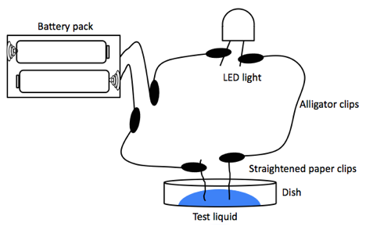

Figure 2 – Diagram of circuit testing conductivity of water

- Create a circuit like the one in Figure 2. Test the conductivity of distilled water, tap water, and salt water by placing the electrodes in each different solution and observing the brightness of the LED. Your electrodes can be close but they cannot touch. Between observations, rinse your electrodes by dipping them into your container of extra tap water and wiping them on a paper towel after each rinse.
- Repeat each test until you are confident in your results. You may need to place your LED on a dark background to more accurately observe its brightness. Record your observations in Table 2.
- Write a hypothesis or explanation that shows what you discovered about conductivity of different types of water. ______________________________________________________________________________________________________________________________________________________________________________________________________________________________________________________________________________
Analysis: Based on your observations and results of the experiment, write what you learned about the conductivity of different solids and different types of water.
___________________________________________________________________________________________________________________________________________________________________________________________________________________________________________________________________________________________________________________________________________________________________________________________________________________________________________________________________________________________
Things to think about:
1. The conductivity of seawater is much higher than fresh water. Did your results support this? Why or why not? ______________________________________________________________________________________________________________________________________________________________________________________________
2. Would you rather be in a boat on a freshwater lake or in the ocean during a thunderstorm? Explain your answer. ______________________________________________________________________________________________________________________________________________________________________________________________

