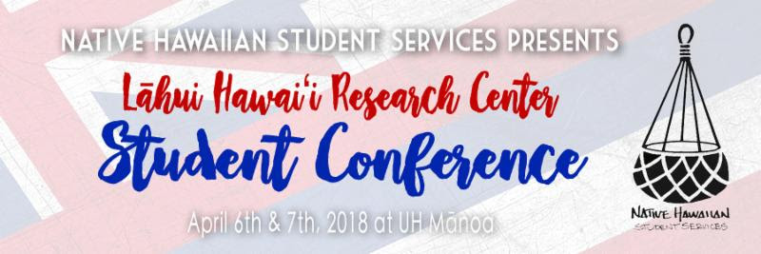
PRESENT AT THE NEXT
Lāhui Hawaiʻi Research Center Conference
April 6 - 7, 2018
(Yes, it is during Merrie Monarch Week)
Submit your presentation proposal here by March 16, 2018!

The second annual Lāhui Hawaiʻi Research Center Student Conference will be on April 6 & 7, 2018. The theme for this year's conference is inspired by Bryan Kamaoli Kuwada's 2015 article and blog entitled "We live in the future. Come join us." Kamaoli so eloquently reminds us that:
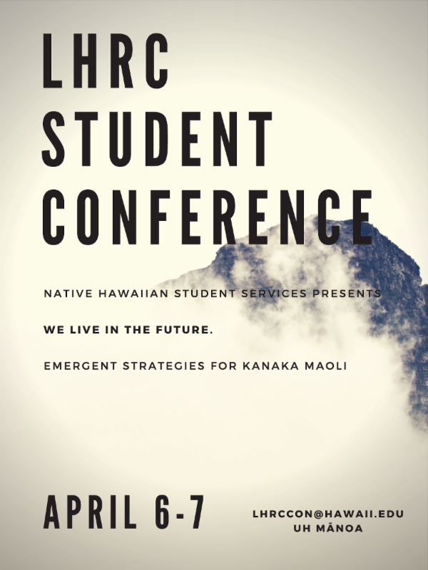
"We always have our ancestors at our back. That certainty gives us a wider possibility of movement, a more supple way to navigate through the world. Standing on our mountain of connections, our foundation of history and stories and love, we can see both where the path behind us has come from and where the path ahead leads. This connection assures us that when we move forward, we can never be lost because we always know how to get back home. The future is a realm we have inhabited for thousands of years. You cannot do otherwise when you rely on the land and sea to survive. All of our gathering practices and agricultural techniques, the patterned mat of loʻi kalo, the breath passing in and out of the loko iʻa, the Ku and Hina of picking plants are predicated on looking ahead. This ensures that the land is productive into the future, that the sea will still be abundant into the future, and that our people will still thrive into the future.

This is the future we are leading the way to, the future we are going to live in, the future our ancestors fought for, the future we still fight for. Come join us."

We are now accepting submissions for our conference and will continue to accept submissions until March 16, 2018. We will also be having workshops in the coming months to prepare you for a submission and presentation. If you have questions, concerns, or need help with preparing your submission, do not hesitate to contact Joy Enomoto or any other member of the NHSS team to help you.

