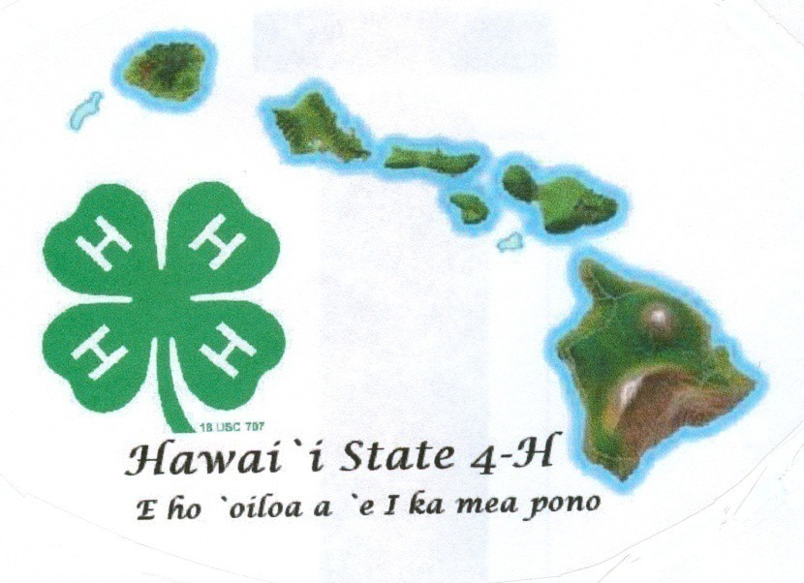
4-H
Senior Portfolio
(Ages 14-19)
20

Name Age (as of Dec. 31) Club Leader Years in 4-H Grade
Email Cell Phone

Member Signature Parent Signature Leader Signature Agent Signature

ANIMALS
- Animal Science
- Beef – Market
- Beef - Breeding
- Dairy Cattle
- Dairy Goat
- Horse
- Horse – Working Ranch
- Meat Goat Breeding
- Meat Goat Market
- Poultry Meat
- Poultry Layer
- Rabbit Breeding
- Rabbit Meat
- Sheep Market
- Sheep Breeding
- Swine
- Dog
- Pets
- Veterinary Science

CAREERS/WORKFORCE PREP
- Entrepreneurship
- Workforce Readiness

CLOVERBUDS
COMMUNICATIVE AND EXPRESSIVE ARTS
- Video
- Creative Writing
- Cultural Arts
- Photography
- Public Speaking
- Theater Arts
- Visual Arts

COMMUNITY / VOLUNTEER SERVICE
- Civic Engagement
- Mentoring
- Leadership

CONSUMER AND FAMILY SCIENCE
- Sewing/Clothing
- Personal Financial Management
Project Focus Area
  - ENVIRONMENTAL (cont.)
  - Entomology
  - Erosion and Soil Control
  - Exploring Your Environment
  - Fishing
  - Forestry
  - Gardening
  - Honey Bee
  - Outdoor Adventures
  - Science Discovery
  - Shooting Sports Rifle
  - Shooting Sports Archery
  - Stormwater Management
  - Wind Energy
  - Water Conservation

FOODS AND NUTIRITION AND HEALTH
  - Cooking
  - Food Preservation
  - Food Safety
  - Nutrition
  - Physical Activity
  - Health
  - Safety

PERSONAL DEVELOPMENT
  - Communication

PLANT SCIENCES
  - Gardening
  - Learn Grow Eat Grow

SCIENCE, TECHNOLOGY, AND ENGINEERING
  - Aerospace
  - Computer
  - Computer Science
  - Electricity
  - Food Science
  - Geospatial
  - Kitchen Chemistry
  - Robotics
  - Science Discovery
  - Science Fun With Physics
  - Small Engines

ENVIRONMENTAL EDUCATION/EARTH SCIENCES
- Backyards and Beyond
- Bicycle
- Butterfly
- STEAM Clothing
- Wind Energy
- Woodworking

4-H Club Project Summary & Learning Experiences - Use the list on the previous page to document work completed for your project(s).

Date | Project Focus  Area (page 1) | What did you do? | What new project/life  skills did you learn? | How have you applied  new knowledge?
EXAMPLE  5/3/20xx | Plants | I learned to identify sandy, silty, clay, peaty and saline soils | I learned soil identification (or using scientific methods) | I took what I learned to determine the soil type I  have in my home garden

Reminder: The 4-H Senior Portfolio shows cumulative 4-H work from grades 4 to current year.

4-H Project Review
We “learn by doing” in 4-H so tell us about your projects. Using the projects listed on the previous page, explain to us your overall project goals, things you learned, knowledge gained, and accomplishments in each of your project areas. If you were in a project more than one year, how did your project change over time? What new experiences have you had that you are grateful for and what did you learn from the experiences? (Limit 3 pgs)

3 Senior Portfolio – Rev. 10-2020

Non Project Activities in 4-H - List all activities completed outside of 4-H projects such as workshops, field trips, camps, contests, etc. and 4-H community/service learning projects such as clean-ups, visitations, and donations. Check if activity was leadership role, community service, public speaking and/or promotion of 4-H. Note level of activity as: Club (C), County (O), State (S), or National (N).

 | HEAD | HEART | HANDS | HEALTH
 | Using Scientific Methods | Communicating | Mastering Technology | Being Responsible
 | Processing Information | Interacting Socially | Learning Through | Developing Self Esteem
 | Understanding Systems | Cooperating | Community Service | Managing Yourself
 | Managing Resources | Sharing | Volunteering | Practicing Integrity and Character
 | Practicing Creativity | Resolving Conflicts | Being a Responsible Citizen | Developing a Sense of Purpose
 | Making Decisions | Valuing Social Justice | Working in a Team | Developing a Positive View of the Future
Life Skills | Solving Problems  Visualizing Information | Valuing Diversity  Building Relationships | Exercising Leadership  Completing a Project | Utilizing Resistance Skills  Being Resilient
 | Learning to Learn | Caring for Others | Motivating Yourself | Managing Stress
 | Thinking Critically | Being Empathic |  | Making Healthy Lifestyle Choices
 | Keeping Records |  |  | Preventing Personal Injury
 | Planning and Organizing |  |  | Expressing Emotions Positively
 | Achieving Goals |  |  | Preventing Disease
 | Navigating in Your Environment
 | Working with Numbers

Date & Activity  Brief description | Knowledge  What did you learn? | Application  How will you apply what you learned? | Level C, O, S, N
Leadership - Assists/mentors others

4 Senior Portfolio – Rev. 10-2020

Date & Activity  Brief description | Knowledge  What did you learn? | Application  How will you apply what you learned? | Level C, O, S, N
Civic Engagement - Gives back to community

Date & Activity  Brief description | Knowledge  What did you learn? | Application  How will you apply what you learned? | Level C, O, S, N
Presentation / Public Speaking - Demonstrates or educates

Date & Activity  Brief description | Knowledge  What did you learn? | Application  How will you apply what you learned? | Level C, O, S, N
Other 4-H Activities – non-project activities outside leadership, civic engagement, or presentation/public speaking

Non 4-H Outside Activities - List all activities completed outside of 4-H such as school, church, sports or community activities in which you had a leadership role that demonstrate life skill development.

Date | What were you involved in? | List leadership responsibilities
EXAMPLE  3/3/20xx | I was part of the senior class banquet planning committee | I was the treasurer for the committee and kept detailed  accounts of the donations and money spent

Provide two photos that best capture your growth in 4-H and describe why and how these photos show growth.

Caption w/dates | Caption w/date

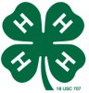
4-H Reflections

Choose four life skills (one each from Head, Heart, Hands and Health) from the Targeting Life Skills Model diagram on page 4 and describe how you have developed each life skill through your 4-H career:

HEAD:

HEART:

HANDS:

HEALTH:

13 Senior Portfolio – Rev. 10-2020

MY 4-H RESUME
(Your resume should include the following basic information; limit 1 page)

Name:

Address:

Cell Number: E-Mail:

Goal Statement (include Career/Educational goals):

Educational Experiences:

Work or Volunteer Experiences:

Special Skills and Abilities:

Letters of Recommendation: Provide two letters of recommendation. You may ask someone who knows you well and can be a teacher, 4-H leader, counselor, mentor, organizational leader or an employer. These letters must be written within the last year and must be signed by the writer. The writer should not be an immediate relative.

Qualifications:

I am prepared to be considered as a State delegate to National 4-H Congress because:

If chosen, and upon returning from National 4-H Congress, I will strengthen my 4-H organization by:

My 4-H Story – Describe who you are and explain your 4-H journey in narrative form.

Your 4-H Story should include the following:
- Tell us some things about yourself.
- Explain what 4-H means to you and how your 4-H experience has shaped your personal development.
- Describe how you will use what you have learned in 4-H in other areas of your life.

HAWAII 4-H PORTFOLIO JUDGING RUBRIC

Name: |  |  |  | Judge:
For each section below, the judge will select the rating (excellent, good or fair) that provides the best overall match for the criteria described. The judge will then select the appropriate points to award for each section.
 | Excellent | Good |  |  | Fair |  | Comments
Organization | Portfolio is well organized and overall appearance neat and clean. Correct punctuation, spelling and grammar used. Form filled out with all  signatures. | The portfolio has some spelling, grammar and organizational inaccuracies. Form lacks complete information |  |  | The portfolio has significant spelling, grammar and/or organizational errors.  Incorrect form used.
Available Pts 5 | 4-5 | 2-3 |  |  | 0-1 |  | Points Awarded:
Project Summary & Review | Member is very active in project involvement. Member clearly explains what was learned in the project and records specific knowledge and skills gained.  Demonstrates growth appropriate for grade and years in 4-H. | Member is active in project involvement. Member lists what was learned in the project, but doesn’t show growth appropriate for grade and years in 4-H. |  |  | Member has limited involvement in the project(s). Member lists a few skills and knowledge. Does not show growth appropriate for grade and years in 4-H.
Available Pts 15 | 11-15 | 6-10 |  |  | 0-5 |  | Points Awarded:
4-H Club Project Summary & Learning Experiences
4-H  Leadership | Gives a clear picture of the responsibilities and duties in each 4-H leadership roles. Only 4-H leadership roles are included. Shows progression as appropriate for grade and years in  4-H. |  | Member involved in 4-H leadership roles, but did not clearly explain the responsibilities and duties of the leadership role. Shows limited  progression as appropriate for grade and years in 4-H. |  |  | Member does not make it clear that the activity is a 4- H role, or includes non-4-H roles. Little or no  progression as appropriate for grade and years in 4-H.
Available Pts 10 | 7-10 |  | 4-6 |  |  | 0-3 | Points Awarded:
4-H Civic Engagement | Member involved in 4-H community service activities. Provides details to give a clear picture of what was  accomplished and involvement. Only lists 4-H community service. |  | Member involved in 4-H community service activities. Entries lack details of what was accomplished  and involvement. Only lists 4-H community service. |  |  | Member involved in no 4-H service activities. Entries do not explain what was accomplished and involved.
Available Pts 10 | 7-10 |  | 4-6 |  |  | 0-3 | Points Awarded:
4-H  Presentation | Member involved in public speaking, demonstration, presentation, and/or promotional activities related to 4-H. Provides details to give a clear picture of what was accomplished and  involvement. Shows progression as appropriate for grade and years in 4-H. |  | Member involved in 4-H presentation activities. Entries lack details of what was accomplished and involvement. Shows progression as appropriate for grade and years in 4-H. |  |  | Member involved in no 4-H presentation activities.  Entries do not explain what was accomplished and involved. Entries do not  show any progression of level.
Available Pts 5 | 4-5 |  | 2-3 |  |  | 0-1 | Points Awarded:
17 Senior Portfolio – Rev. 10-2020

HAWAII 4-H PORTFOLIO JUDGING RUBRIC

Name: |  |  | Judge:
For each section below, the judge will select the rating (excellent, good or fair) that provides the best overall match for the criteria described. The judge will then select the appropriate points to award for each section.
 | Excellent | Good |  | Fair | Comments
4-H Other Activities | Member participated in numerous other 4-H activities and events at club, county, and state levels. Provides details to give a clear picture of what was accomplished and involvement.  Shows progression as appropriate for grade and years in 4-H. | Member involved in other 4-H activities and events. Entries lack details of what was accomplished and involvement. Shows progression as appropriate for grade and years in 4-H. |  | Member involved in no other 4-H activities or events.  Entries do not explain what was accomplished and involved. Entries do not  show any progression of level.
Available Pts 5 | 4-5 | 2-3 |  | 0-1 | Points Awarded:
Activities Outside 4-H | Lists significant non-4-H experiences in school, community, sports, church or other organizations such as leadership, community service, awards  and recognition. | Lists some non-4-H experiences in school, community, sports, church or other organizations such as leadership, community service,  awards and recognition. |  | Lists few non-4-H experiences.
Available Pts 5 | 4-5 | 2-3 |  | 0-1 | Points Awarded:
4-H Photos | Photos show member’s growth in project, leadership, service and activities that represent 4-H  involvement. Photos are dated with detailed captions. | Photos show project involvement but fail to show leadership and service involvement. Captions are missing or lack details. |  | Photos show limited involvement. Captions are missing or lack details and dates.
Available Pts 5 | 4-5 | 2-3 |  | 0-1 | Points Awarded:
4-H Reflection | Member reflects and communicates how they’ve practiced the four different H’s. | Member reflects and communicates how they’ve practiced some of the four different H’s. |  | Member does not show how they’ve practiced the four different H’s.
Available Pts 10 | 7-10 | 4-6 |  | 0-3 | Points Awarded:
Resume & Letters | Member has completed resume and two signed letters of recommendation. | Member partially completes resume or has one signed letter of recommendation. |  | Member does not have resume or signed letters of recommendation.
Available Pts 5 | 4-5 | 2-3 |  | 0-1 | Points Awarded:
4-H Story | Story shows personal growth and development in 4-H. Highlights leadership and community service.  Gives details to demonstrate how 4-H has influenced life. | Story shows some personal growth and development in 4-H. Some details demonstrate how 4-H has influenced life. |  | Few details are provided regarding personal growth and development in 4-H.
Available Pts 25 | 17-25 | 8-16 |  | 0-7 | Points Awarded:
 |  |  |  |  | TOTAL POINTS

18 Senior Portfolio – Rev. 10-2020

