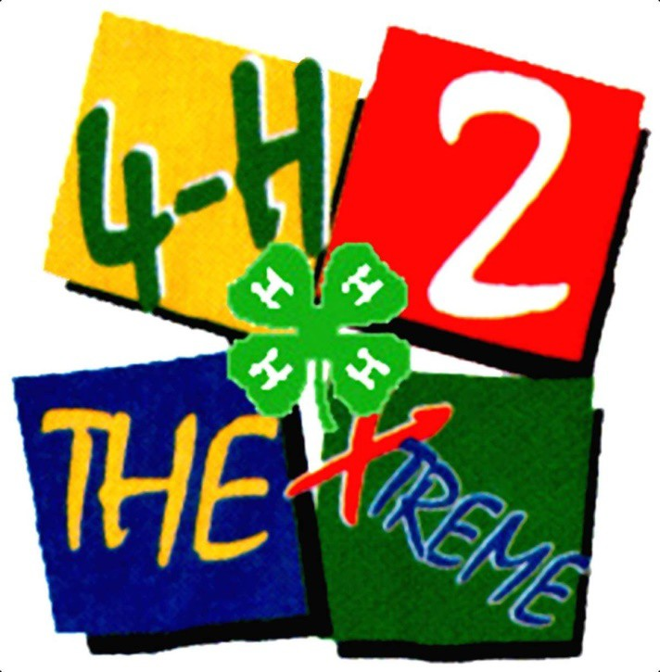

4-H Record Book

Cloverbud

(Ages 5-8)

20

Cloverbud – Rev. 10-2021

4-H Pledge
I pledge:
My
HEAD to clearer thinking
My
HEART to greater loyalty,
My
HANDS to larger service, and
My HEALTH to better living,
For my club, my community,
my country and my world.

Motto: To Make the Best Better Slogan: Learn by Doing

“This is Me” Page

My name is

Number of years in 4-H

I am years old

My 4-H club name is

There are members in my club

My club leader(s) name is/are:

The “I’ve Really Done It” Page
Fill this page as you read, learn and share in each meeting. List or draw a picture of each activity you do and the date you do it. See how many you can do! You can also include in each square, what you liked or disliked about each learning activity.

Club Meeting Activities
Example:

October

Baked banana cupcakes

It was Yummy!

Club Meeting Activities

4-H Reflections
(to be done at the end of the year)

Draw or write about the best thing you did in 4-H this year.

Draw or write about one thing you have learned from 4-H this year.

Cloverbud Record Book Reviewer Comments

Name: Club:

☺

☺

☺

