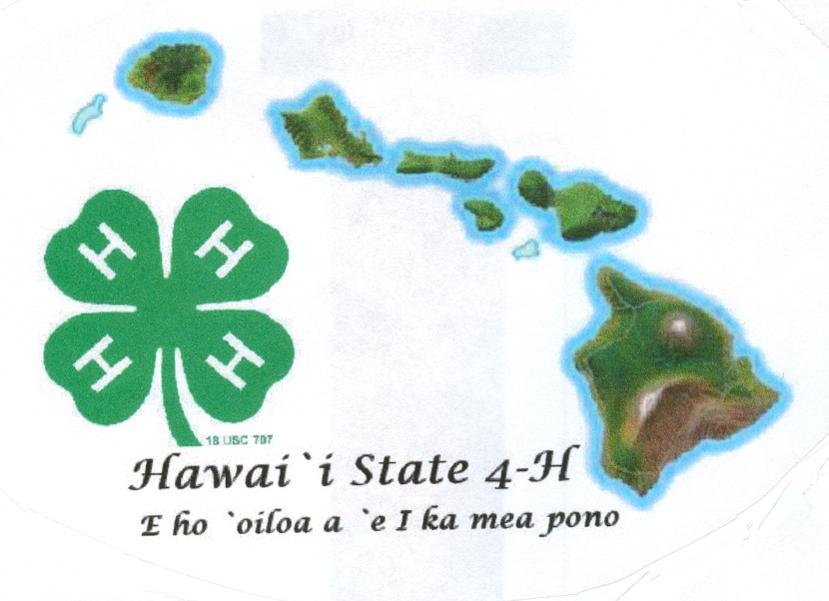
4-H
Record Book
Senior
(Ages 14-19)
20___
Name Age (as of Dec. 31)
Club Leader
Year in 4-H Year in this project Grade
Member Signature
Parent Signature
Leader Signature
Agent Signature

Project Focus Area

ANIMALS
- Animal Science
- Beef – Market
- Beef - Breeding
- Dairy Cattle
- Dairy Goat
- Horse
- Horse – Working Ranch
- Meat Goat Breeding
- Meat Goat Market
- Poultry Meat
- Poultry Layer
- Rabbit Breeding
- Rabbit Meat
- Sheep Market
- Sheep Breeding
- Swine
- Dog
- Pets
- Veterinary Science

CAREERS/WORKFORCE PREP
- Entrepreneurship
- Workforce Readiness

CLOVERBUDS

COMMUNICATIVE AND EXPRESSIVE ARTS
- Video
- Creative Writing
- Cultural Arts
- Photography
- Public Speaking
- Theater Arts
- Visual Arts

COMMUNITY / VOLUNTEER SERVICE
- Civic Engagement
- Mentoring
- Leadership

CONSUMER AND FAMILY SCIENCE
- Sewing/Clothing
- Personal Financial Management

ENVIRONMENTAL EDUCATION/EARTH SCIENCES
- Backyards and Beyond
- Bicycle
- Butterfly

- ENVIRONMENTAL (cont.)
- Entomology
- Erosion and Soil Control
- Exploring Your Environment
- Fishing
- Forestry
- Gardening
- Honey Bee
- Outdoor Adventures
- Science Discovery
- Shooting Sports Rifle
- Shooting Sports Archery
- Stormwater Management
- Wind Energy
- Water Conservation

FOODS AND NUTIRITION AND HEALTH
- Cooking
- Food Preservation
- Food Safety
- Nutrition
- Physical Activity
- Health
- Safety

PERSONAL DEVELOPMENT
- Communication

PLANT SCIENCES
- Gardening
- Learn Grow Eat Grow

SCIENCE, TECHNOLOGY, AND ENGINEERING
- Aerospace
- Computer
- Computer Science
- Electricity
- Food Science
- Geospatial
- Kitchen Chemistry
- Robotics
- Science Discovery
- Science Fun With Physics
- Small Engines
- STEAM Clothing
- Wind Energy
- Woodworking

4-H Club Project Summary & Learning Experiences - Use the list on the previous page to document work completed for your project(s). Complete this chart OR complete and submit a project book for your project(s)

 | I will be submitting a project book for my project(s) and will not complete the table below.
 | I am completing the table below and not submitting a project book(s)
Date | Project Focus Area (page 1) | What did you do? | What new project/life skills did you learn? | How will you apply new knowledge?
EXAMPLE  5/3/20xx | Plants | I learned to identify sandy, silty, clay, peaty and saline soils | I learned to use problem solving skills and the scientific method | I can use these skills when working in the school garden

Non Project Activities in 4-H - List all activities completed outside of 4-H projects such as workshops, field trips, camps, contests, etc. and 4-H community/service learning projects such as clean-ups, visitations, and donations. Check if activity was leadership role, community service, public speaking and/or promotion of 4-H. Note level of activity as: Club (C), County (O), State (S), or National (N).

Life Skills | HEAD  Using Scientific Methods  Processing Information  Understanding Systems  Managing Resources  Practicing Creativity  Making Decisions  Solving Problems  Visualizing Information  Learning to Learn  Thinking Critically  Keeping Records  Planning and Organizing  Achieving Goals  Navigating in Your Environment  Working with Numbers | HEART  Communicating  Interacting Socially  Cooperating  Sharing  Resolving Conflicts  Valuing Social Justice  Valuing Diversity  Building Relationships  Caring for Others  Being Empathic | HANDS  Mastering Technology  Learning Through  Community Service  Volunteering  Being a Responsible Citizen  Working in a Team  Exercising Leadership  Completing a Project  Motivating Yourself | HEALTH  Being Responsible  Developing Self Esteem  Managing Yourself  Practicing Integrity and Character  Developing a Sense of Purpose  Developing a Positive View of the Future  Utilizing Resistance Skills  Being Resilient  Managing Stress  Making Healthy Lifestyle Choices  Preventing Personal Injury  Expressing Emotions Positively  Preventing Disease

Date & Activity  Brief description | Knowledge  What did you learn? | Application  How will you apply what you learned? | Level  C, O, S, N
Leadership - Assists/mentors others
Date & Activity  Brief description | Knowledge  What did you learn? | Application  How will you apply what you learned? | Level  C, O, S, N
Civic Engagement - Gives back to community
Date & Activity  Brief description | Knowledge  What did you learn? | Application  How will you apply what you learned? | Level  C, O, S, N
Presentation / Public Speaking - Demonstrates or educates
Date & Activity  Brief description | Knowledge  What did you learn? | Application  How will you apply what you learned? | Level  C, O, S, N
Other 4-H Activities – non-project activities outside leadership, civic engagement, or presentation/public speaking

Non 4-H Outside Activities - List all activities completed outside of 4-H such as school, church, sports or community activities in which you had a leadership role that demonstrates life skill development.

Date | What were you involved in? | List leadership responsibilities
EXAMPLE  3/3/20xx | I was part of the senior class banquet planning committee | I was the treasurer for the committee and kept detailed accounts of the donations and money spent

Provide two photos that best capture your growth in 4-H this year and describe why and how these photos show growth.
Caption w/date | Caption w/date

My 4-H Story– Use several paragraphs to explain your journey through 4-H this year in a story format. Use the bullets below as some ideas to include in your story but do not just address each bullet. (2 pg limit)
- What are the most important life skills you have learned as a result of your 4-H work this year?
- How has 4-H encouraged you to do service within your club, school or community this year?
- How has 4-H helped develop your leadership skills this year? Give examples of when you were a leader.
- What 2 or 3 things did you learn from being in 4-H this year?
- What are some things you would like to do better, improve upon, or do more of next year?
- What do you consider to be your greatest successes in this 4-H year?

Scoring Sheet for Senior Record Book

Name: County: Category:

 | Excellent |  | Good | Fair | Comments
Organization | Portfolio is well organized and overall appearance neat and clean. Correct punctuation, spelling and grammar used. Form filled out with all signatures. |  | The portfolio has some spelling, grammar and organizational inaccuracies. Form lacks complete information | The portfolio has significant spelling, grammar and/or organizational errors. Incorrect form used.
Available Pts 5 | 4-5 |  | 2-3 | 0-1 | Points Awarded:
Project Summary & Review | Member is very active in project involvement. Member clearly explains what was learned in the project and records specific knowledge and skills gained. |  | Member is active in project involvement. Member lists what was learned in the project, but doesn’t explain. | Member has limited involvement in the project(s). Member lists a few skills and knowledge.
Available Pts 15 | 11-15 |  | 6-10 | 0-5 | Points Awarded:
4-H Club Project Summary & Learning Experiences
4-H Leadership | Gives a clear picture of the responsibilities and duties in each 4-H leadership roles. Only 4-H leadership roles are included. |  | Member involved in 4-H leadership roles, but did not clearly explain the responsibilities and duties of the leadership role. | Member does not make it clear that the activity is a 4-H role, or includes non-4-H roles.
Available Pts 10 | 7-10 |  | 4-6 | 0-3 | Points Awarded:
4-H Civic Engagement | Member involved in 4-H community service activities. Provides details to give a clear picture of what was accomplished and involvement. Only lists 4-H community service. |  | Member involved in 4-H community service activities. Entries lack details of what was accomplished and involvement. Only lists 4-H community service. | Member involved in no 4-H service activities. Entries do not explain what was accomplished and involved.
Available Pts 10 | 7-10 |  | 4-6 | 0-3 | Points Awarded:
4-H Presentation | Member involved in public speaking, demonstration, presentation (club or public), and/or promotional activities related to 4-H. Provides details to give a clear picture of what was accomplished and involvement. |  | Member involved in 4-H presentation activities. Entries lack details of what was accomplished and involvement. | Member involved in no 4-H presentation activities. Entries do not explain what was accomplished and involved.
Available Pts 10 | 7-10 |  | 4-6 | 0-3 | Points Awarded:
4-H Other Activities | Member participated in numerous other 4-H activities and events at club, county, and state levels. Provides details to give a clear picture of what was accomplished and involvement. |  | Member involved in other 4-H activities and events. Entries lack details of what was accomplished and involvement. | Member involved in no other 4-H activities or events. Entries do not explain what was accomplished and involved.
Available Pts 10 | 7-10 |  | 4-6 | 0-3 | Points Awarded:
Activities Outside 4-H | Lists significant non-4-H experiences in school, community, sports, church or other organizations such as leadership, community service, awards and recognition. |  | Lists some non-4-H experiences in school, community, sports, church or other organizations such as leadership, community service, awards and recognition. | Lists few non-4-H experiences.
Available Pts 5 | 4-5 |  | 2-3 | 0-1 | Points Awarded:
4-H Photos | Photos show member’s growth in project, leadership, service and activities that represent 4-H involvement. Photos are dated with detailed captions. |  | Photos show project involvement but fail to show leadership and service involvement. Captions are missing or lack details. | Photos show limited involvement. Captions are missing or lack details and dates.
Available Pts 10 | 7-10 |  | 4-6 | 0-3 | Points Awarded:
4-H Story | Story shows personal growth and development in 4-H. Highlights leadership and community service. Gives details to demonstrate how 4-H has influenced life. |  | Story shows some personal growth and development in 4-H. Some details demonstrate how 4-H has influenced life. | Few details are provided regarding personal growth and development in 4-H.
Available Pts 25 | 17-25 |  | 8-16 | 0-7 | Points Awarded:
Judge’s Initials |  |  | Ribbon Color |  | TOTAL POINTS

