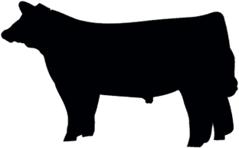
Hawai‘i 4-H Market Beef
Project Book 20___

Form 319b (5/20)

Member Information
Name |  | Age (as of Dec 31st) | Junior or Senior
Address
City | State | Zip Code | County
Club Name |  | Club Leader's Name
Year in 4-H | Year in this project | County or State Exhibit | Grade in School

Animal Information
Name | Breed Composition | Color and Sex | 4-H Tag / Tattoo Number
Breeder Name and Address |  |  | Breeder Phone Number

Commitment to Stewardship and Welfare
I WILL:  1. Provide comfortable housing for my animal(s).  2. Feed my animal(s) on time each day.  3. Provide my animal(s) with clean water at all times.  4. Keep my animal(s) free from parasites.  5. Strive to keep my animal(s) in good health.  6. Be kind to animals and act in their best interest. | 7. Complete mandatory quality assurance trainings.  8. Keep an accurate record of my projects.  9. Submit required paperwork and forms on-time  10. Always show good sportsmanship in competition.  11. Participate in 4-H Club activities  12. Complete my project requirements.
Quality Assurance Completion Date:
I UNDERSTAND that the presence of any drug, antibiotic or biological residue in my project animal at slaughter will result in the condemnation of the carcass and forfeiture of all sale proceeds and premiums. I certify that any drug, antibiotic or biological which may have been administered by me, or any other person, was done so in strict compliance with the manufacturer’s label requirements.
Member  Signature | Parent  Signature
Leader  Signature | Agent  Signature

PROJECT PLAN

Before purchasing animals, begin by completing a plan. Review your plan with your 4-H project leader.

Learning Goals
What do you hope to learn about and what skills do you want to practice while doing this project? Is this your first year in this project, or have you raised a market beef animal prior to this?

My goal for my project this year | What I need to do to reach this goal

Planning Notes or Questions You Would Like Answered

PROJECT MANAGEMENT RECORD

Record this information at the time(s) you purchase your animal and start the project.

Name of Animal |  | Breed | Color
Birthdate of Animal | Tag / Tattoo Number | Purchase Weight | Purchase Date
Purchased From |  | Total Purchase Price

Did you replace the original animal that you originally started the project with? If so, describe that experience and put the original animal’s information below.

ANIMAL CARE & MANAGEMENT

Beef Performance Record: You must have a beginning weight and a starting date. The “Expected” column should be completed at the start date and starting weights were measured. The ending weight and date for these records will be completed at the final weigh in.

Performance Statistics |  | Example | Expected | Actual
Starting Date of Project | a. | 11/24/19
Ending Date of Project | b. | 6/2/20
Days on Feed = (b – a) | c. | 190
Starting Weight, lb | d. | 600
Final Weight, lb | e. | 1200
Total Weight Gain, lb = (e – d) | f. | 600
Average Daily Gain, lbs. / day = (f / c) | g. | 3.16
Feed Efficiency, lb feed / lb gain (i / f) | h. | 7.5 | 7.5
Amount of Feed Needed, lb = (h x f) | i. | 4500

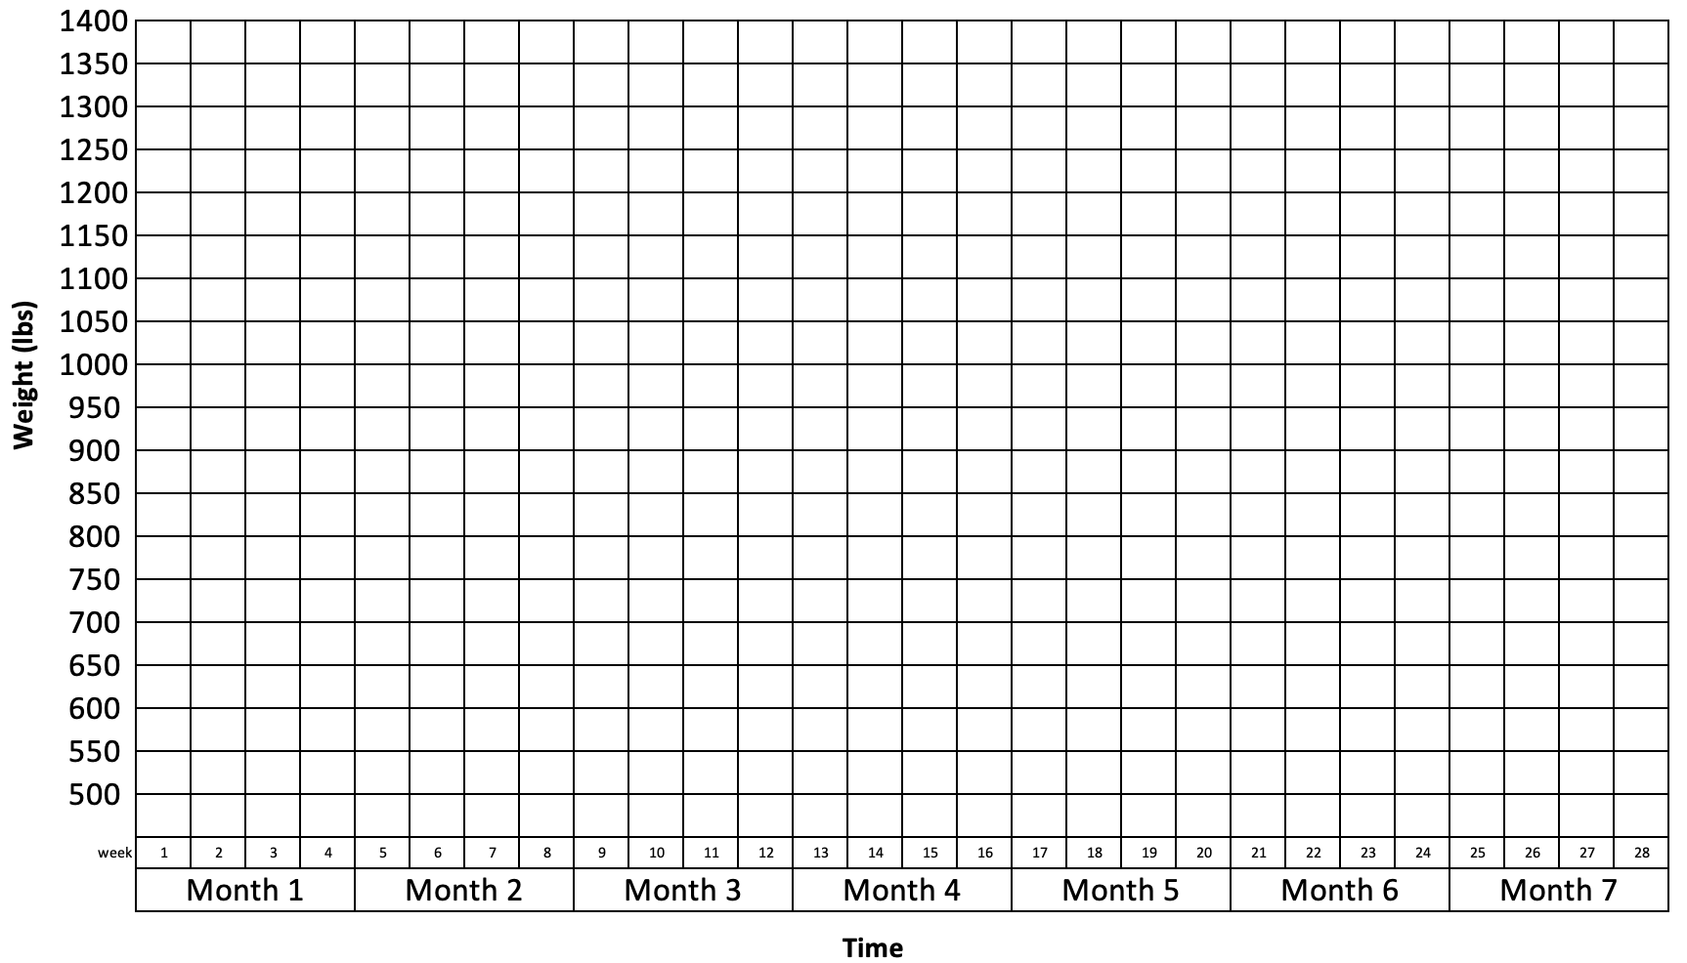
Market Beef Performance Graph. Chart the estimated weight of your animal on this graph throughout the duration of the project. Use a tape to estimate weight if a scale is not available.
Treatment Records: List vaccinations, medications (includes medicated feed) and products used for internal and external parasite control. Treatment records must be kept for one year after the last day of treatment, whereas feed medications records must be kept for two years. Attach prescriptions and other medication information to the back of this Project Book.

Date and  Time | Condition  Being Treated | Estimated Animal Weight | Treatment Amount | Treatment Route  (Oral, SQ, IM, drench, etc.) | Who gave Treatment? | Withdrawal Time | Rx?  (Yes/No)

List your veterinarian’s name, address, and phone number in the space below.

PROJECT FINANCIAL RECORD

Feed Purchased and Associated Costs. Record purchases of feed and supplements (minerals, vitamins, salt, etc.) throughout the project period. Note if feed is complete feed (starter, grower or finisher), concentrate or a supplement.

Date | Name of Feed (if applicable).  Place Feed was Purchased From. | Size per bag  (lbs) | Cost per bag  ($) | Amount Purchased (lbs) | Total  Cost  ($)
Totals

Did you have any issues feeding your animal or obtaining feed this year? Please explain. __________________________
Treatment Expenses: List expenses for dewormers, vaccines and or veterinary costs related to your project.
Date | Item Description | Purchased From | Lot Number | Expiration Date | Total Cost  ($)
Totals

Other Expenses: List expenses for other items used in the project (fencing, panels, ropes, show sticks, halters, feed troughs, waterers, other supplies, etc.)
Date | Item Description | Quantity | Item Cost  ($) | Total Cost  ($)
Totals

Exhibit Expenses: List expenses for other items used in the project (transportation costs, lodging, pen fees, other supplies, etc.)

Date | Item Description and Expected Lifespan | Total Cost  ($)
 | Totals

Financial Plan and Records. The “Expected” column should be completed at the start date and starting weights were measured. The ending weight and date for these records will be completed at the final weigh in.

Expenses | Expected | Actual
- Animal Purchase
- Feed Costs
- Treatment Expenses
- Other Expenses
- Pen Fees / Exhibit Expenses
- Total Expenses (Add lines from A to E)
Income | Expected | Actual
- Animal Sales Income Needed to Break Even (same as F)
- Final Weight of Animal
- Price Needed ($/lb) = Sales Income (G) / Final Weight (H)

Project Finances. Describe the financial agreements you have made with financial institutions, your family (parents) and/or other persons regarding this project.

Summary of Time Spent with Your Project:

Hours spent providing general care (daily feeding, watering, pen cleaning, etc.) | hours
Hours spent preparing for show (training to lead, washing, clipping, etc.) | hours
Hours spent elsewhere (vaccination, veterinarian visits, quality assurance, etc.) | hours
Total number of hours spent with your project | hours

Livestock Project Knowledge and Skills I Gained This Year
Check each item below that you learned or improved in 4-H during the past year. Some may not apply to your project.
I learned or improved my ability to…
Beginning Skills |  | Intermediate Skills
 | Identify 6 breeds. |  | Using a picture or an actual animal, describe an ideal market animal or breeding animal, using judging terms.
 | Identify at least 2 characteristics for 3 breeds |  | Help a new member learn to correctly identify 15-20 external parts for their project animal(s).
 | Identify 10-15 parts of you project animal. |  | Describe the proper procedure for deworming a project animal.
 | Explain 3 steps you would take to prevent disease in a project animal. |  | Explain the meaning of the following terms: carbohydrates, fat, minerals, protein, vitamins, fat soluble and water soluble.
 | Identify equipment needed to raise a market or breeding animal. |  | Give a demonstration on 9 different breeds, including the origin, breed characteristics and use of each breed.
 | Define the following terms for specie(s) you are raising: ewe/gilt/doe/heifer, ram/boar/billy/bull, wether, yearling, loin, purebred and grade. |  | Read one or more livestock publications.
 | Visit a local grocery store, list of 2 different retail cuts of meat and identify the location of these two retail cuts on a live animal. |  | Help a new 4-H member update his/her record book.
 | Explain 2 types of parasites and name one of each kind that are common to your species. |  | Discuss the various records that a livestock producer should keep and explain why each is useful.
 | Identify 5 main categories of nutrients needed for growth and production. |  | Interview a livestock producer in order to discover the desired characteristics of the ideal market or breeding animal.
 | Name 8 or more feed ingredients commonly fed to your project animal and tell the major use each serves in the ration as a source of protein, vitamins, minerals, fat, carbohydrates and water. |  | Judge a class of 4 market or breeding animals and give oral reasons on your placings.
 | Explain 2 sections of a feed tag and what is included in the section. |  | Name 3 methods of identification used for livestock.
 | Identify the following undesirable characteristics: post-legged, weak pasterns, cow-hocked, overshot or undershot jaw. |  | Name 5 management practices you use with your project animal.
 | Describe 3 methods of giving an injection and the preferred sites. |  | Correctly identify 8 different cuts of meat produced by a market animal and explain where the cut of meat comes from.
 | Teach your project animal to lead and describe the proper way to put on a halter and the proper side to lead your project animal. |  | Name 9 by-products from the specie(s) you are raising for your project.
 | Compete in a showmanship class. |  | Explain the difference between a monogastric and ruminant animal.
 | Identify 5 things that are essential in keeping your animal healthy and clean at the fair. |  | Explain what a parasite is and name 4 that are common to your project animal.
 | Other (optional): |  | Other (optional):
 | Other (optional): |  | Other (optional):

Advanced Skills
 | Help a new 4-Her in a sheep project prepare their animal for showing. |  | Explain 3 different ways to ensure high quality meat in a market project.
 | Help a new 4-Her select an animal for their sheep project. |  | Demonstrate how to properly store, label and account for all drug products and medicated feeds.
 | Describe what carcass measurements are listed for lamb, and listing all the formulas for all the areas. |  | Plan & organize a county wide workshop.
 | Compile a list of all retail cuts of meat that are produced by a market lamb and identify from which wholesale cut each comes. |  | Help a new 4-H member update his/her record book.
 | Plan a waste disposal system for a sheep operation. |  | Shadow someone in a sheep-related career
 | Join a Junior breed association or your local state wool growers association. |  | Describe 3 of the unique properties of wool.
 | Research the different careers available in animal science and visit a business that offers opportunities for people with animal science degrees. |  | Achieve a target rate of gain of 0.75 pounds or more per day on your project animal.
 | Develop a plan to deal with questions from the media on livestock practices. |  | Other (optional):
 | Research the various livestock marketing alternatives for your sheep project. |  | Other (optional):
 | Lead an activity in your club meeting to teach members in your club how to write a proper Thank you note to award donors, buyers and anyone who helped you with your project. |  | Other (optional):

MY PROJECT STORY

Project Conclusion:
- What are some observations from working with your animal throughout the course of the project? How did the animal’s actual performance compare to the expected performance?

- What would you change or do the same the next time you begin a market beef project? For example: different feed, different breed, frame size of animal, etc. you would start with.

- Did you achieve your learning goals? What was most helpful in achieving them? What problems did you experience?

Appendix Section: Attach pictures-with captions, newspaper articles, feed labels, or other artifact, etc., that support your Market Beef project)

LIVESTOCK PROJECT RECORD BOOK SCORE SHEET
Name: County:
Category:
Ribbon Color:
Judges’s Initials:
Please include any other specific comments or suggestions for improvement here:

Instructions: Check one box for the statement on each row that best describes each record book section/criteria. Provide specific details in the comment boxes if necessary.
 | Excellent | Good | Fair | Needs Improvement | Comments
Cover Page - Complete with signatures
Project Plan & Project Management Record – All sections are completed.
Animal Care & Management - Member completed information on Animal Performance and
Treatment Records.
Project Financial Plan - Expected column completed, Actual column completed; completed feed, treatment, exhibit and other expenses records; calculations accurate and reasonable. Has description of
financial agreement.
Summary of Time Spent with Project Animal - All sections are completed.
Treatment Records - All sections are completed.
Knowledge & Skill Sheet - Member documented 6-7 new skills learned.
Story – Story is well organized. One idea follows another in a logical sequence with clear transactions. Story summarizes learning experiences. Minimal spelling, punctuation, or grammatical errors. Story contains creative detail and/or description that contribute to the
reader’s enjoyment.

Subcutaneous (SQ) means treatment under the skin; intramuscular (IM) means treatment in the muscle.

