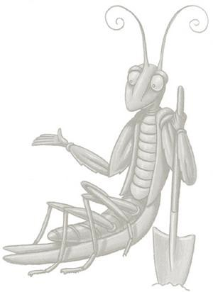
My Giant Pumpkin Records

Date | Temp | Weather  (sunny, cloudy, rainy, etc.) | Pumpkin Measurement | Comments

