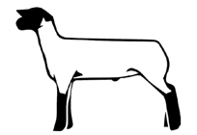
Hawai‘i 4-H Market Lamb
Project Book 20___

Form 319b (5/20)

Member Information
Name |  | Age (as of Dec 31st) | Junior or Senior
Address
City | State | Zip Code | County
Club Name |  | Club Leader's Name
Year in 4-H | Year in this project | County or State Exhibit | Grade in School

Animal Information
Name | Breed Composition | Color and Sex | 4-H Tag / Tattoo Number
Breeder Name and Address |  |  | Breeder Phone Number

Commitment to Stewardship and Welfare
I WILL:  1. Provide comfortable housing for my animal(s).  2. Feed my animal(s) on time each day.  3. Provide my animal(s) with clean water at all times.  4. Keep my animal(s) free from parasites.  5. Strive to keep my animal(s) in good health.  6. Be kind to animals and act in their best interest. | 7. Complete mandatory quality assurance trainings.  8. Keep an accurate record of my projects.  9. Submit required paperwork and forms on-time  10. Always show good sportsmanship in competition.  11. Participate in 4-H Club activities  12. Complete my project requirements.
Quality Assurance Completion Date:
I UNDERSTAND that the presence of any drug, antibiotic or biological residue in my project animal at slaughter will result in the condemnation of the carcass and forfeiture of all sale proceeds and premiums. I certify that any drug, antibiotic or biological which may have been administered by me, or any other person, was done so in strict compliance with the manufacturer’s label requirements.
Member  Signature | Parent  Signature
Leader  Signature | Agent  Signature

PROJECT PLAN

Before purchasing animals, begin by completing a plan. Review your plan with your 4-H project leader.

Learning Goals
What do you hope to learn about and what skills do you want to practice while doing this project? Is this your first year in this project, or have you raised a market lamb animal prior to this?

My goal for my project this year | What I need to do to reach this goal

Planning Notes or Questions You Would Like Answered

PROJECT MANAGEMENT RECORD

Record this information at the time(s) you purchase your animal and start the project.

Name of Animal |  | Breed | Color
Birthdate of Animal | Tag / Tattoo Number | Purchase Weight | Purchase Date
Purchased From |  | Total Purchase Price

Did you replace the original animal that you originally started the project with? If so, describe that experience and put the original animal’s information below.

ANIMAL CARE & MANAGEMENT

Lamb Performance Record: You must have a beginning weight and a starting date. The “Expected” column should be completed at the start date and starting weights were measured. The ending weight and date for these records will be completed at the final weigh in.

Performance Statistics |  | Example | Expected | Actual
Starting Date of Project | a. | 3/1/20
Ending Date of Project | b. | 6/1/20
Days on Feed = (b – a) | c. | 90
Starting Weight, lb | d. | 70
Final Weight, lb | e. | 135
Total Weight Gain, lb = (e – d) | f. | 65
Average Daily Gain, lbs. / day = (f / c) | g. | 0.72
Feed Efficiency, lb feed / lb gain (i / f) | h. | 7.5 | 7.5
Amount of Feed Needed, lb = (h x f) | i. | 487.50

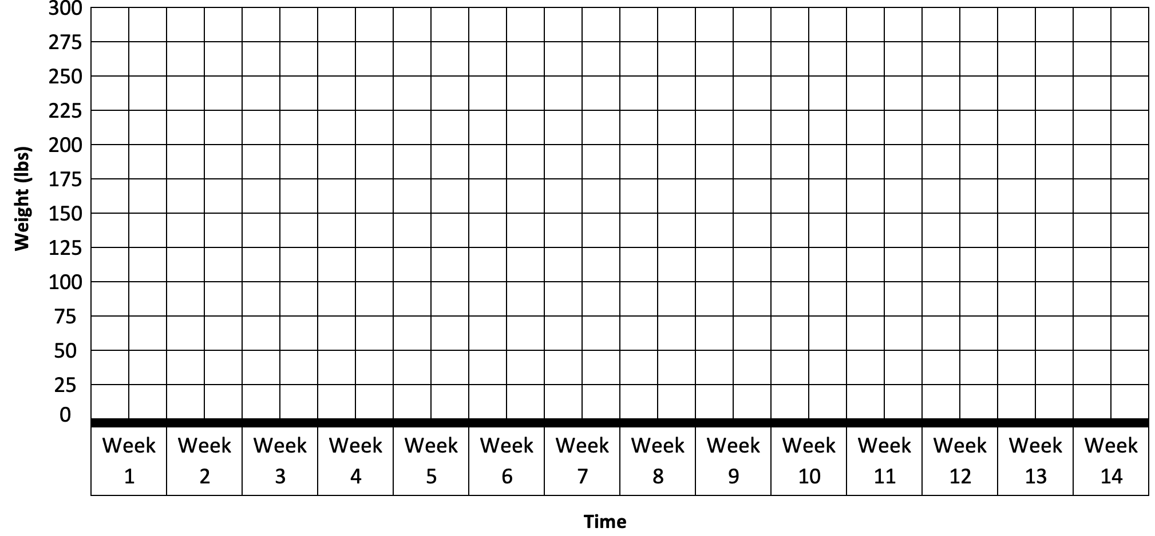
Market Lamb Performance Graph. Chart the estimated weight of your animal on this graph throughout the duration of the project. Use a tape to estimate weight if a scale is not available.

Treatment Records: List vaccinations, medications (includes medicated feed) and products used for internal and external parasite control. Treatment records must be kept for one year after the last day of treatment, whereas feed medications records must be kept for two years. Attach prescriptions and other medication information to the back of this Project Book.

Date and  Time | Condition  Being Treated | Estimated Animal Weight | Treatment Amount | Treatment Route  (Oral, SQ, IM, drench, etc.) | Who gave Treatment? | Withdrawal Time | Rx?  (Yes/No)

List your veterinarian’s name, address, and phone number in the space below.

PROJECT FINANCIAL RECORD

Feed Purchased and Associated Costs. Record purchases of feed and supplements (minerals, vitamins, salt, etc.) throughout the project period. Note if feed is complete feed (starter, grower or finisher), concentrate or a supplement.

Date | Name of Feed (if applicable).  Place Feed was Purchased From. | Size per bag  (lbs) | Cost per bag  ($) | Amount Purchased (lbs) | Total  Cost  ($)
Totals

Did you have any issues feeding your animal or obtaining feed this year? Please explain. __________________________
Treatment Expenses: List expenses for dewormers, vaccines and or veterinary costs related to your project.
Date | Item Description | Purchased From | Lot Number | Expiration Date | Total Cost  ($)
Totals

Other Expenses: List expenses for other items used in the project (fencing, panels, ropes, show sticks, halters, feed troughs, waterers, other supplies, etc.)
Date | Item Description | Quantity | Item Cost  ($) | Total Cost  ($)
Totals

Exhibit Expenses: List expenses for other items used in the project (transportation costs, lodging, pen fees, other supplies, etc.)

Date | Item Description and Expected Lifespan | Total Cost  ($)
 | Totals

Financial Plan and Records. The “Expected” column should be completed at the start date and starting weights were measured. The ending weight and date for these records will be completed at the final weigh in.

Expenses | Expected | Actual
- Animal Purchase
- Feed Costs
- Treatment Expenses
- Other Expenses
- Pen Fees / Exhibit Expenses
- Total Expenses (Add lines from A to E)
Income | Expected | Actual
- Animal Sales Income Needed to Break Even (same as F)
- Final Weight of Animal
- Price Needed ($/lb) = Sales Income (G) / Final Weight (H)

Project Finances. Describe the financial agreements you have made with financial institutions, your family (parents) and/or other persons regarding this project.

Summary of Time Spent with Your Project:

Hours spent providing general care (daily feeding, watering, pen cleaning, etc.) | hours
Hours spent preparing for show (training to lead, washing, clipping, etc.) | hours
Hours spent elsewhere (vaccination, veterinarian visits, quality assurance, etc.) | hours
Total number of hours spent with your project | hours

Knowledge and Skills I Gained This Year
Check each item below that you learned or improved in 4-H during the past year.

I learned or improved my ability to…

HEAD (Independence) |  | HANDS (Generosity)
 | try something new | work with others
 | set goals for myself | work within a group
 | plan a project | work within a committee
 | keep myself organized | work with adults
 | keep track of finances | get past differences to reach a goal
 | keep records of my work | help others succeed
 | gain knowledge of my project | make something with my hands
 | find information on things that interest me | explore a career interest
 | use resources wisely | follow directions
 | participate in a business meeting | lead others
 | run a business meeting | find ways to make a positive contribution to society
 | make wise choices and decisions | understand the importance of community service
 | solve problems | see that my efforts can make a difference
 | learn from my mistakes | take the initiative to start something on my own
 | understand it’s ok to change my mind if I need to
 | pay attention to instructions

HEART (Belonging) |  | HEALTH (Mastery)
 | speak confidently in front of a group | understand my strengths and weaknesses
 | give a public presentation | finish something I started
 | share my feelings or point of view | be proud of my accomplishments
 | make myself understood without being loud | accept change
 | listen to other people | see that my character can affect my situation
 | respect someone else’s feelings | take responsibility for my own words and actions
 | resolve differences of opinion | deal with winning and losing gracefully
 | appreciate my cultural heritage | be careful and practice safety
 | accept people who are different from me | appreciate the importance of good health
 | get along with other kids | stay healthy
 | make others feel welcome | feel good about myself
 | stand up for others
 | make new friends
 | appreciate the importance of friendships in my life

MY PROJECT STORY

Project Conclusion:
- What are some observations from working with your animal throughout the course of the project? How did the animal’s actual performance compare to the expected performance?

- What would you change or do the same the next time you begin a market lamb project? For example: different feed, different breed, frame size of animal, etc. you would start with.

- Did you achieve your learning goals? What was most helpful in achieving them? What problems did you experience?

Appendix Section: Attach pictures-with captions, newspaper articles, feed labels, or other artifact, etc., that support your Market Lamb project)

Subcutaneous (SQ) means treatment under the skin; intramuscular (IM) means treatment in the muscle.

