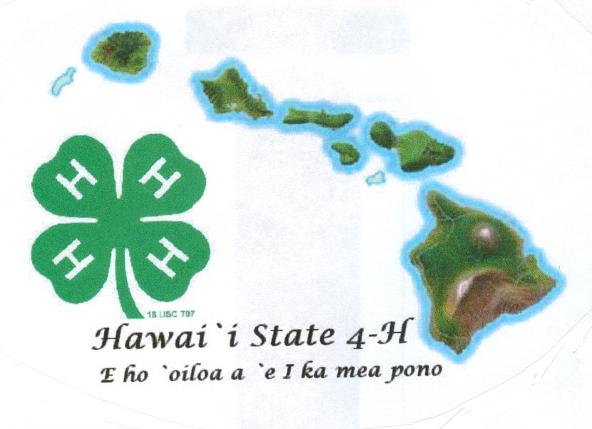
4-H
Record Book
Senior
(Ages 14-19)
20___
Name Age (as of Dec. 31)
Club Leader
Year in 4-H Year in this project Grade
Member Signature
Parent Signature
Leader Signature
Agent Signature

Non 4-H Project Activities - List all activities completed outside of 4-H projects such as workshops, field trips, camps, contests, etc. and 4-H community/service learning projects such as clean-ups, visitations, and donations. Also include school, church, sports or community activities that demonstrate life skill development. Check if activity was leadership role, community service, public speaking and/or promotion of 4-H. Note level of activity as: Club (L), County (C), State (S), or National (N).

Life Skills | HEAD  Using Scientific Methods  Processing Information  Understanding Systems  Managing Resources  Practicing Creativity  Making Decisions  Solving Problems  Visualizing Information  Learning to Learn  Thinking Critically  Keeping Records  Planning and Organizing  Achieving Goals  Navigating in Your Environment  Working with Numbers | HEART  Communicating  Interacting Socially  Cooperating  Sharing  Resolving Conflicts  Valuing Social Justice  Valuing Diversity  Building Relationships  Caring for Others  Being Empathic | HANDS  Mastering Technology  Learning Through  Community Service  Volunteering  Being a Responsible Citizen  Working in a Team  Exercising Leadership  Completing a Project  Motivating Yourself |  |  | HEALTH  Being Responsible  Developing Self Esteem  Managing Yourself  Practicing Integrity and Character  Developing a Sense of Purpose  Developing a Positive View of the Future  Utilizing Resistance Skills  Being Resilient  Managing Stress  Making Healthy Lifestyle Choices  Preventing Personal Injury  Expressing Emotions Positively  Preventing Disease
Date & Activity  Brief description | Knowledge  What did you learn? | Application  How can you use what you learned? | 4-H (Y/N) | Level  L, C,  S, N | Leadership  Assists others | Civic  Gives  back | Present  Demonstrates or educates | Promote 4-H  to others

Provide two photos that best capture your growth in the project. Identify the setting and people in the photo.

4-H Project Summary & Learning Experiences- Complete project books for each project you participated in this year.
My 4-H Story– Paragraphs should connect and tell a complete story of your journey through 4-H this year.
- What are the most important life skills you have learned as a result of your 4-H work this year?
- How has 4-H encouraged you to do service within your club, school or community this year?
- How has 4-H helped develop your leadership skills this year? Give examples of when you were a leader.
- What 2 or 3 things did you learn from being in 4-H this year?
- What are some things you would like to do better, improve upon, or do more of next year?
- What do you consider to be your greatest successes in this 4-H year?
Scoring Sheet for Record Book
Name: County: Category:

Instructions: Check one box for each row that best describes each criteria. Provide details in the comment box if needed.
 | Excel | Good | Fair | Needs Improve | Comments
Cover Page-Complete with signatures
Selection, Goals & Other Records
Non-4-H Project Activities
- List only included activities outside project work
- List includes activities outside 4-H
- Activities marked with level, life skill and contribution
- More than five entries were listed
- All areas of chart are complete
- Member demonstrates involvement outside club level
- Member displays leadership involvement
- Member shows involvement within community and beyond
- Member shows involvement beyond 4-H
My 4-H Story
Organization -The story sections are well organized. One idea follows another in a logical sequence with clear transitions.
Main Project – The story summarizes activities and learning experiences for the year.
Spelling/Punctuation/Grammar -There are minimal spelling, punctuation, or grammatical errors in the story.
Creativity -The story contains creative details and/or descriptions that contribute to the reader's enjoyment.
Completeness – The story answers all of the questions in a satisfactory way.
Please include any other specific comments or suggestions for improvement here:

RIBBON COLOR:

Judge’s Initials:

Judge’s Initials:
Ribbon Color: _______________

