CE%20sig

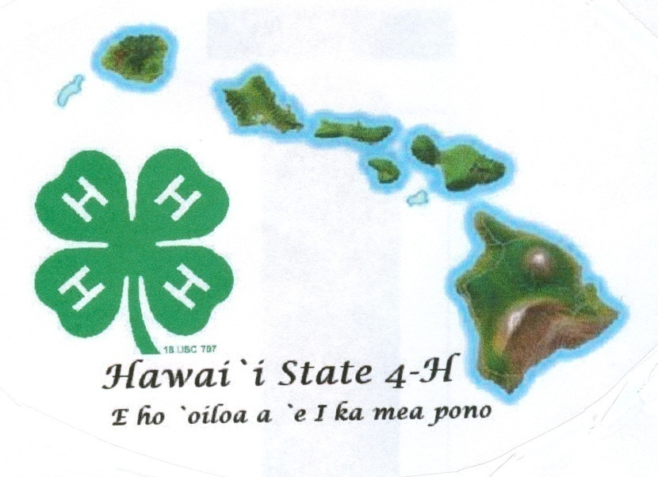

Name Age (as of Dec. 31)

Club Leader

Years in 4-H Grade

Member Signature Date

Parent Signature Date

Leader Signature Date

Agent Signature Date

**4-H**

**Senior Portfolio**

**(Ages 14-19)**

**20___**

Revised April 2019

**j0162916**

**Why Record Books?**

**4-H Experiential Learning**

4-H has a long history of “learning by doing”. Experiential learning happens when a person gets involved in an activity, looks back at the experience critically, determines what was useful or important to remember from the activity, and uses this information in doing something else. It is more than doing activities as experiential learning involves discussing what was done (what), thinking about was learned (so what) and applying new skills and information to a real life experience (now what).

4-H records are a written expression of learning experiences. From their records, members can see to what degree they participate in club events and activities and how well they meet their own personal goals. Records also relate experiences in leadership and community service and in addition can be used as a tool for members to assess the skills and knowledge learned and how it can be applied to real life experiences.

4-H records help youth to:

• Establish goals •Assume responsibility for record keeping

• Collect and record information •Evaluate progress in certain areas

**Life Skills**

By keeping 4-H records, members obtain experience and training that is of value throughout their adult lives. Life Skills are categorized under the four H’s in the 4-H clover – *Head*, *Heart*, *Hands*, and *Health*. These skills are useful long after the project is over. The chart below shows some examples of life skills.

|  |  |  |  |
| --- | --- | --- | --- |
| **HEAD** | **HEART** | **HANDS** | **HEALTH** |
| Using Scientific Methods  Processing Information  Understanding Systems  Managing Resources  Practicing Creativity  Making Decisions  Solving Problems  Visualizing Information  Learning to Learn  Reasoning  Thinking Critically  Keeping Records  Planning and Organizing  Achieving Goals  Navigating in Your-Environment  Working with Numbers | Communicating  Interacting Socially  Cooperating  Sharing  Resolving Conflicts  Valuing Social Justice  Valuing Diversity  Building Relationships  Caring for Others  Being Empathic | Mastering Technology  Learning Through  Community Service  Volunteering  Being a Responsible Citizen  Working in a Team  Exercising Leadership  Completing a Project  Motivating Yourself | Being Responsible  Developing Self Esteem  Managing Yourself  Practicing Integrity and Character  Developing a Sense of Purpose  Developing a Positive View of the Future  Utilizing Resistance Skills  Being Resilient  Managing Stress  Making Healthy Lifestyle Choices  Preventing Personal Injury  Expressing Emotions Positively  Preventing Disease |

**Project Focus Area**

**ANIMALS**

* Animal Science
* Beef – Market
* Beef - Breeding
* Dairy Cattle
* Dairy Goat
* Horse
* Horse – Working Ranch
* Meat Goat Breeding
* Meat Goat Market
* Poultry Meat
* Poultry Layer
* Rabbit Breeding
* Rabbit Meat
* Sheep Market
* Sheep Breeding
* Swine
* Dog
* Pets
* Veterinary Science

**CAREERS/WORKFORCE PREP**

* Entrepreneurship
* Workforce Readiness

**CLOVERBUDS**

**COMMUNICATIVE AND EXPRESSIVE ARTS**

* Video
* Creative Writing
* Cultural Arts
* Photography
* Public Speaking
* Theater Arts
* Visual Arts

**COMMUNITY / VOLUNTEER SERVICE**

* Civic Engagement
* Mentoring
* Leadership

**CONSUMER AND FAMILY SCIENCE**

* Sewing/Clothing
* Personal Financial Management

**ENVIRONMENTAL EDUCATION/EARTH SCIENCES**

* Backyards and Beyond
* Bicycle
* Butterfly

**ENVIRONMENTAL (cont.)**

* Entomology
* Erosion and Soil Control
* Exploring Your Environment
* Fishing
* Forestry
* Gardening
* Honey Bee
* Outdoor Adventures
* Science Discovery
* Shooting Sports Rifle
* Shooting Sports Archery
* Stormwater Management
* Wind Energy
* Water Conservation

**FOODS AND NUTIRITION AND HEALTH**

* Cooking
* Food Preservation
* Food Safety
* Nutrition
* Physical Activity
* Health
* Safety

**PERSONAL DEVELOPMENT**

* Communication

**PLANT SCIENCES**

* Gardening
* Learn Grow Eat Grow

**SCIENCE, TECHNOLOGY, AND ENGINEERING**

* Aerospace
* Computer
* Computer Science
* Electricity
* Food Science
* Geospatial
* Kitchen Chemistry
* Robotics
* Science Discovery
* Science Fun With Physics
* Small Engines
* STEAM Clothing
* Wind Energy
* Woodworking

***The 4-H Senior Portfolio shows cumulative 4-H work from grades 4 to current year.***

**4-H Project Review**

We “learn by doing” in 4-H so tell us about your projects. Using the project areas listed on the previous page, explain to us your project goals, things you learned, knowledge gained, and accomplishment in each of your project areas. If you were in a project more than one year, how did your project change over time?  What new experiences have you had that you are grateful for and what did you learn from the experiences? (Limit 3 pgs)

**4-H Club Project Summary & Learning Experiences -** Use the chart on page 2 to document work completed for your project (s).

|  |  |  |  |  |
| --- | --- | --- | --- | --- |
| Date | **Focus Area**  **(select from page 2)** | **What did you do?** | **What new project/life skills did you learn?** | **How have you applied new knowledge?** |
| **EXAMPLE**  5/3/2016 | Plants | I learned to identify sandy, silty, clay, peaty and saline soils | I learned soil identification  (or using scientific methods) | I took what I learned to determine the type of soil I have at home in my garden |
|  |  |  |  |  |
|  |  |  |  |  |
|  |  |  |  |  |
|  |  |  |  |  |
|  |  |  |  |  |
|  |  |  |  |  |
|  |  |  |  |  |
|  |  |  |  |  |
|  |  |  |  |  |
|  |  |  |  |  |
|  |  |  |  |  |
|  |  |  |  |  |
|  |  |  |  |  |
|  |  |  |  |  |
|  |  |  |  |  |
|  |  |  |  |  |
|  |  |  |  |  |
|  |  |  |  |  |
|  |  |  |  |  |
|  |  |  |  |  |

**Other 4-H Activities (County/State/National)** - List all your 4-H activities outside of your project(s), such as workshops, field trips, camps, county/state judging contests, Youth-Adult Partnership training, state fair, and participation in National 4-H Council sponsored programs, like the NYSD events and 4-H Paper Clover Campaign.

|  |  |  |  |  |
| --- | --- | --- | --- | --- |
| Date | **Activity** | **Level**  **(Club, County, State, National)** | **What did you learn?** | **How have you applied what you learned?** |
| **EXAMPLE**  4/18/2016 | | 4-H Floriculture Workshop | County | I learned how to make floral arrangements | I now make floral table arrangements for our 4-H banquets. |
|  |  |  |  |  |
|  |  |  |  |  |
|  |  |  |  |  |
|  |  |  |  |  |
|  |  |  |  |  |
|  |  |  |  |  |
|  |  |  |  |  |
|  |  |  |  |  |
|  |  |  |  |  |
|  |  |  |  |  |
|  |  |  |  |  |
|  |  |  |  |  |
|  |  |  |  |  |
|  |  |  |  |  |
|  |  |  |  |  |
|  |  |  |  |  |
|  |  |  |  |  |
|  |  |  |  |  |
|  |  |  |  |  |
|  |  |  |  |  |

**Leadership** - List your *4-H leadership* roles and responsibilities. Include learning experiences where you have taken the lead in planning, organizing, and implementing/teaching. Also include general 4-H leadership roles such as Club Officer, County 4-H Federation, or County Committees.

|  |  |  |  |
| --- | --- | --- | --- |
| Date | **Leadership Activity** | **Level**  **(Club, County, State, National)** | Responsibilities/ Duties/ Accomplishments |
| **EXAMPLE**  7/20/17 to 7/24/18 | After School STEM Program | Club | Created lesson plans for STEM Program.  Taught two lessons for 20 youth in grades K-1. |
| 2/15/15 to 2/28/15 | Demonstration Day | County | Secured location/facilities.  Obtained 3 judges.  MC for the event. |
|  |  |  |  |
|  |  |  |  |
|  |  |  |  |
|  |  |  |  |
|  |  |  |  |
|  |  |  |  |
|  |  |  |  |
|  |  |  |  |
|  |  |  |  |
|  |  |  |  |
|  |  |  |  |
|  |  |  |  |
|  |  |  |  |
|  |  |  |  |
|  |  |  |  |
|  |  |  |  |
|  |  |  |  |
|  |  |  |  |
|  |  |  |  |

**Citizenship.**  4‑H citizenship activities empower youth to be well-informed citizens who are actively engaged in their communities and the world. List 4-H community service projects showing how you have contributed toward the ***betterment of your community***. Examples might include: organizing, managing, and/or coordinating beach cleanup efforts, organizing a bicycle safety class, participating in a city government meeting, etc.

|  |  |  |  |
| --- | --- | --- | --- |
| Date | **Service Activity** | **Importance of Project and Impact on Community** | **# of Hours** |
| **EXAMPLE**  3/1/16 to 4/16/16 | | Organized a food drive for our 4-H club, so members could donate produce they grew to the food bank | This allowed me to learn and use new leadership skills and the donated food will help feed the homeless in our community | 20 |
|  |  |  |  |
|  |  |  |  |
|  |  |  |  |
|  |  |  |  |
|  |  |  |  |
|  |  |  |  |
|  |  |  |  |
|  |  |  |  |
|  |  |  |  |
|  |  |  |  |
|  |  |  |  |
|  |  |  |  |
|  |  |  |  |
|  |  |  |  |
|  |  |  |  |
|  |  |  |  |
|  |  |  |  |
|  |  |  |  |
|  |  |  |  |
|  |  |  |  |

**Activities Outside 4-H –** List your ***non 4-H activities*** and leadership roles in school, church, sports, etc.

|  |  |  |
| --- | --- | --- |
| Date | **What you were involved in?** | List leadership responsibilities |
| EXAMPLE  8-2015 to 8-2016 | **KUMC Church Youth Group** | Planned and led one church service. |
| 10-2014 to 5-2017 | | Key Club President (2016-2017)  Vice President (2014-2015) | Helped with organizing a March of Dimes Walk-a-Thon and Blood Drive. |
|  |  |  |
|  |  |  |
|  |  |  |
|  |  |  |
|  |  |  |
|  |  |  |
|  |  |  |
|  |  |  |
|  |  |  |
|  |  |  |
|  |  |  |
|  |  |  |
|  |  |  |
|  |  |  |
|  |  |  |
|  |  |  |
|  |  |  |
|  |  |  |
|  |  |  |
|  |  |  |
|  |  |  |

**Project Photos** -Paste two photos, with captions, that best captures your growth in 4-H. Identify the setting and people in the photos.

________________



**4-H Reflections**

Choose four life skills (one each from Head, Heart, Hands and Health) from the Targeting Life Skills Model diagram on page 1 and describe how you have developed each life skill through your 4-H career:

**HEAD:**

**HEART:**

**HANDS:**

**HEALTH:**

**MY 4-H RESUME**

(Your resume should include the following basic information; limit 1 page)

Name:

Address:

Cell Number: E-Mail:

Goal Statement (include Career/Educational goals):

Educational Experiences:

Work or Volunteer Experiences:

Special Skills and Abilities:

**Letters of Recommendation**: Provide two letters of recommendation. You may ask someone who knows you well and can be a teacher, 4-H leader, counselor, mentor, organizational leader or an employer. These letters must be written within the last year and **must be signed by the writer**. The writer should not be an immediate relative.

**Qualifications:**

I am prepared to be considered as a State delegate to National 4-H Congress because:

If chosen, and upon returning from National 4-H Congress, I will strengthen my 4-H organization by:

**My 4-H Story** – Describe yourself and explain your 4-H journey in narrative form.

**Your 4-H Story should include the following:**

* **Tell us some things about yourself.**
* **Explain what 4-H means to you and how your 4-H experience has shaped your personal development.**
* Describe how you will use what you have learned in other areas of your life.

Minimum 2 pages; Maximum 6 pages, double-spaced