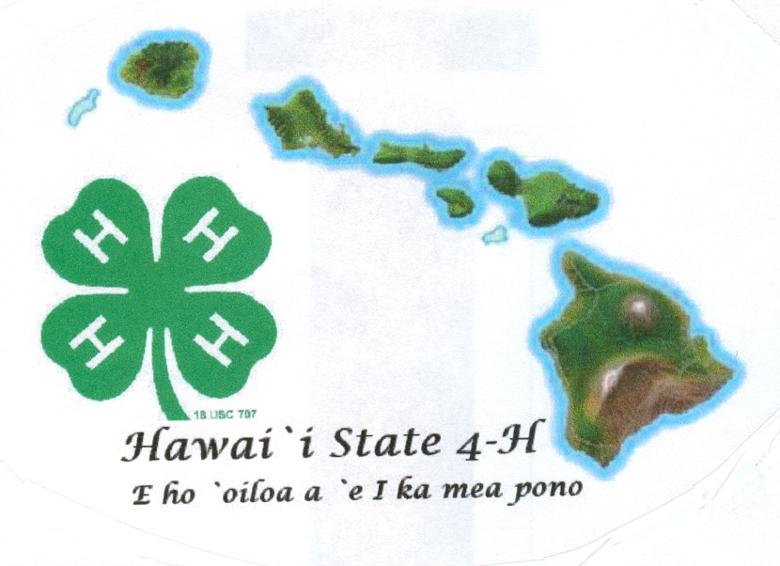

Revised November 2017

Name Age (as of Dec. 31)

Club Leader

Year in 4-H Year in this project Grade

Member Signature

Parent Signature

Leader Signature

Agent Signature

**4-H**

**Record Book**

**Junior**

**(Ages 9-13)**

**20___**

j0162916

**4-H Experiential Learning**

4-H has a long history of “learning by doing”. Experiential learning happens when a person gets involved in an activity, looks back at the experience critically, determines what was useful or important to remember from the activity, and uses this information in doing something else. It is more than doing activities as experiential learning involves discussing what was done (what), thinking about was learned (so what) and applying new skills and information to a real life experience (now what).

**Why Record Books?**

4-H records are a written expression of learning experiences. From their records, members can see to what degree they participate in club events and activities and how well they meet their own personal goals. Records also relate experiences in leadership and community service and in addition can be used as a tool for members to assess the skills and knowledge learned and how it can be applied to real life experiences.

4-H records help youth to:

• Establish goals •Assume responsibility for record keeping

• Collect and record information •Evaluate progress in certain areas

**Life Skills**

By keeping 4-H records, members obtain experience and training that is of value throughout their adult lives. Life Skills are categorized under the four H’s in the 4-H clover – *Head*, *Heart*, *Hands*, and *Health*. These skills are useful long after the project is over. The chart below shows some examples of life skills.

|  |  |  |  |
| --- | --- | --- | --- |
| **HEAD** | **HEART** | **HANDS** | **HEALTH** |
| Using Scientific Methods  Processing Information  Understanding Systems  Managing Resources  Practicing Creativity  Making Decisions  Solving Problems  Visualizing Information  Learning to Learn  Reasoning  Thinking Critically  Keeping Records  Planning and Organizing  Achieving Goals  Navigating in Your-Environment  Working with Numbers | Communicating  Interacting Socially  Cooperating  Sharing  Resolving Conflicts  Valuing Social Justice  Valuing Diversity  Building Relationships  Caring for Others  Being Empathic | Mastering Technology  Learning Through  Community Service  Volunteering  Being a Responsible Citizen  Working in a Team  Exercising Leadership  Completing a Project  Motivating Yourself | Being Responsible  Developing Self Esteem  Managing Yourself  Practicing Integrity and Character  Developing a Sense of Purpose  Developing a Positive View of the Future  Utilizing Resistance Skills  Being Resilient  Managing Stress  Making Healthy Lifestyle Choices  Preventing Personal Injury  Expressing Emotions Positively  Preventing Disease |

**4-H Goals**– List what you hope to accomplish and explain why you chose these goals.

* My main 4-H project is:
* **I chose this project because...**

* **List 3 things you want to learn in your 4-H project this year.**

* **What do you want to accomplish in 4-H this year?**

* **What new activities or projects do you want to try this year?**

**4-H Club Project Summary & Learning Experiences**-Use the following chart to document club/project work completed *during and outside of your club meetings*.

|  |  |  |  |
| --- | --- | --- | --- |
| Date | **What did you do?** | **What new project/life skill did you learn?** | **Did you meet one of your goals?** |
| ***Example: 5/3/2015*** | ***We learned to identify sandy, silty, clay, peaty and saline soils*** | ***I learned soil identification/using scientific methods*** | ***Yes*** |
|  |  |  |  |
|  |  |  |  |
|  |  |  |  |
|  |  |  |  |
|  |  |  |  |

**4-H Club Project Summary & Learning Experiences** (continued)

|  |  |  |  |
| --- | --- | --- | --- |
| Date | **What did you do?** | **What new project/life skill did you learn?** | **Did you meet one of your goals?** |
|  |  |  |  |
|  |  |  |  |
|  |  |  |  |
|  |  |  |  |
|  |  |  |  |
|  |  |  |  |
|  |  |  |  |
|  |  |  |  |
|  |  |  |  |
|  |  |  |  |

# of meetings your club held __________ # of meetings you attended ____________

**Other 4-H Activities (County/State/National)** - List all your county, state, national 4-H activities completed, such as workshops, field trips, camps, county/state judging contests, youth-adult partnerships, state fair, and participation in National 4-H Council sponsored programs, like the NYSD events and 4-H Paper Clover Campaign.

|  |  |  |  |
| --- | --- | --- | --- |
| Date | **What you were involved in?** | **What new skills you learned?** | **How will you use the new skills that you learned?** |
| ***Example: 4/18/2015*** | ***4-H Floriculture Workshop*** | ***I learned how to make floral arrangements*** | ***Will help to make floral table arrangements for our 4-H recognition banquet.*** |
|  |  |  |  |
|  |  |  |  |
|  |  |  |  |
|  |  |  |  |
|  |  |  |  |
|  |  |  |  |

**Leadership**- List *4-H leadership* acts you performed to assist others during your 4-H year. Also include general 4-H leadership such as Club Officer, County 4-H Federation, or County Committees.

|  |  |  |  |
| --- | --- | --- | --- |
| Date | **What you were involved in?** | **What did you learn?** | **Club, County or State Level?** |
| ***Example: 10/6/14 to 5/22/15*** | ***Club Secretary*** | ***How to take minutes and handle correspondence*** | ***Club*** |
|  |  |  |  |
|  |  |  |  |
|  |  |  |  |
|  |  |  |  |

**Citizenship** - List *4-H community service* or *4-H service learning* projects which show how you have given back on a voluntary basis. Examples might include: clean ups, collections, care packets, visitations, donations, and presentations.

|  |  |  |  |
| --- | --- | --- | --- |
| Date | **What you were involved in?** | **Importance or Impact on Community** | **# of Hours** |
| ***Example: 3/16/15*** | ***Donated produce I grew to the food bank*** | ***Donated food will help feed the homeless in our community*** | ***3*** |
|  |  |  |  |
|  |  |  |  |
|  |  |  |  |
|  |  |  |  |

**Activities Outside 4-H** –List school activities, church activities, sports, *non-4-H*leadership projects, *non-4-H* community service projects, etc.

|  |  |
| --- | --- |
| Date | **What you were involved in?** |
| ***Example: 8/2014 to 10/2014*** | ***Football*** |
|  |  |
|  |  |
|  |  |
|  |  |

**Project Photos** - Paste two photos, with captions, that best capture your 4-H year.



**Caption:**



**Caption:**

**My 4-H Story**– Using complete sentences in the following bullets, explain your journey through 4-H this year.

* **Tell us some things about you and your family that you want to share.**
* **I joined 4-H this year because...**
* What 2 or 3 things I learned from 4-H this year were…
* Describe2 problems you encountered this year when doing your 4-H project work. If you had no problems, just describe new challenges or new experiences you had this year.
* **My favorite parts of 4-H were...**
* **Some things I would like to do better, improve upon, or do more of next year in 4-H are...**
* What do you consider to be your greatest successes in this 4-H year?
* Go back to page 2 and look at what you wrote for your 4-H goals. Did you reach your goals? Describe how you reached/met your goals. If goals were not met, explain what prevented you from reaching your goals.

**Name: County: Category:**

|  |  |  |  |  |  |  |  |  |  |
| --- | --- | --- | --- | --- | --- | --- | --- | --- | --- |
| **Instructions:** Check one box for each row that best describes each criteria. Provide details in the comment box if needed. | | | | | | | | | |
|  | **Excel** | **Good** | | | **Fair** | | **Needs Improve** | **Comments** | |
| **Cover Page-**Complete with signatures |  | |  |  | |  | |  | |
| **Selection, Goals & Other Records** | | | | | | | |  | |
| **Project Selection –** Member clearly describes reason for selecting main project. |  | |  |  | |  | |  |
| **Project Goals –** Current and future goals are clearly outlined for 4-H project(s). |  | |  |  | |  | |  |
| **4-H Project Summary & Learning Experience-**E effectively demonstrates high level of involvement in 4-H meetings |  | |  |  | |  | |  |
| **Other 4-H Activities (County, State, National) -** Member effectively demonstrates involvement in 4-H opportunities outside of 4-H club level |  | |  |  | |  | |  |
| **Leadership -** Member displays leadership involvement |  | |  |  | |  | |  |
| **Citizenship -** Member shows involvement within community and beyond |  | |  |  | |  | |  |
| **Activities Outside 4-H -** Member shows involvement beyond 4-H |  | |  |  | |  | |  |
| **Project Photos -**Photos are detailed, attractive, creative, and relate to the member’s 4-H involvement. |  | |  |  | |  | |  |
| **My 4-H Story** |  | |  |  | |  | |  |
| **Organization -**The story sections are well organized. One idea follows another in a logical sequence with clear transitions. |  | |  |  | |  | |  |
| **Main Project –** The story summarizes activities and learning experiences within the main project category. |  | |  |  | |  | |  |
| **Spelling/Punctuation/Grammar** -There are minimal spelling, punctuation, or grammatical errors in the story. |  | |  |  | |  | |  |
| **Creativity -**The story contains creative details and/or descriptions that contribute to the reader's enjoyment. |  | |  |  | |  | |  |
|  |  | |  |  | |  | |  |

Please include any other specific comments or suggestions for improvement here:

**RIBBON COLOR:**

**Judge’s Initials:**

**Judge’s Initials:**

**Ribbon Color:** _______________